**Meiosis Cheat Sheet**

**Meiosis I**

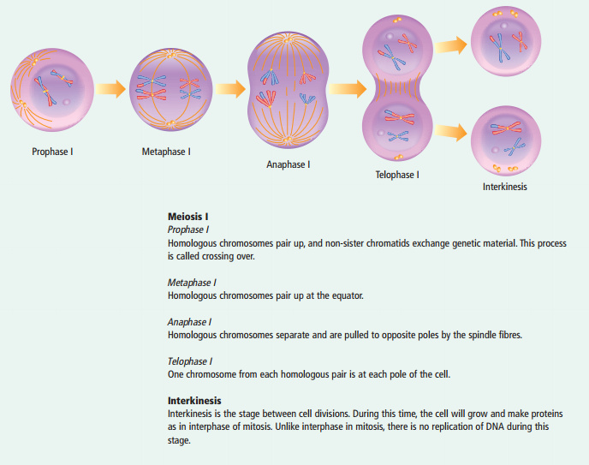

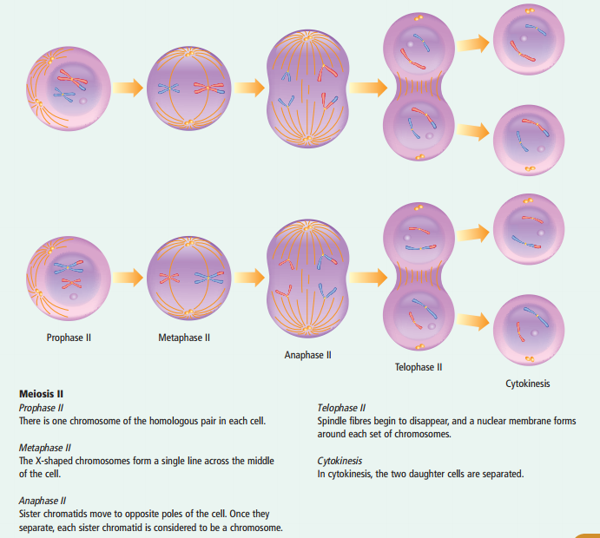**Meiosis II**