**4.2 Properties of VISIBLE LIGHT** Name:

Date:

Block:

(Refer to BC Science 8 pp. 144 – 151)



**WAVE MODEL OF LIGHT**



* The **_______________________________** is a model of light behavior that represents light travelling as a wave.



* In this model, **__________** is a type of wave that travels through empty space and transfers energy from one location to another, such as from the Sun to the Earth.



* + **_________________________** is electromagnetic radiation (light energy) you can see.



**REFRACTION OF LIGHT**



* **refraction:** _________________________________________



**_______________________________________________**



* + This occurs due to a change in the wave’s _____________.
    - Waves travel at different speeds in different ________________.



* Light waves ____________ when they pass from one material to another.



* + For example, when a light wave passes from _______ into ____________.



* + A light wave also refracts when it passes through a ____________.



* + - White light, such as sunlight is made up of waves having different ___________________ and _______________________.



* + - 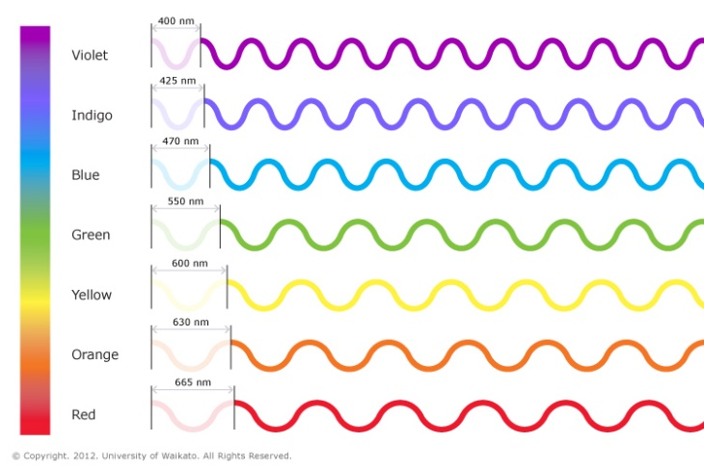When a light wave passes through a prism the different wavelengths are refracted by _________________ _____________.



* + - * + Longer wavelengths are refracted _________than shorter wavelengths.



This causes different colours to be _________________when they come out of the prism.



**Colours of the Rainbow**



* ___________ ______________ also refract light.
* When white light is separated into its different colours, this band of colour is called the visible **___________________**.



* + - * The range of __________________ of visible light.
* The seven most visible colours of the spectrum are:

Red, Orange, Yellow, Green, Blue, Indigo, Violet

__ __ __ __ __ __ __



211588



* The colour ______ has the longest wavelength and lowest frequency.



* The colour _________ has the shortest wavelength and highest frequency.



**Producing the Visible Spectrum**

* In the 17th century, Sir Isaac Newton did an experiment to prove that light contains ___________.



* 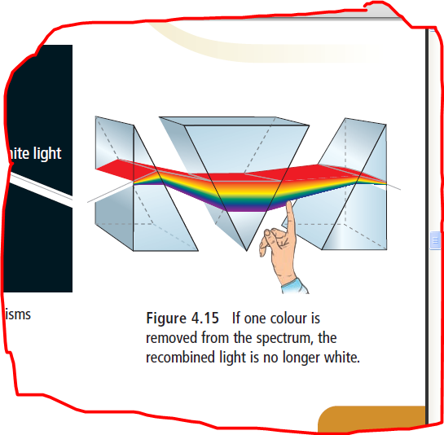He used a prism to _________________ white light into a spectrum of colours and a reverse prism to ___________________ the colours into white light again.







* He showed that colour was a _______________ of visible light.
  + He proposed that white light, such as sunlight, is the result of ___________ together all the different colours of light.



**Colour and Reflection**



* **Reflection:** _________________________________________



**_______________________________________________**

* When white light strikes an object, some colours are __________________ and some are __________________.



* + Only the ______________ colours can be seen.



* + - For example, yellow cloth reflects ____________ and absorbs ______________________________.



* Only three colours of light are needed to produce all the colours of the rainbow: ________, _____________, and _________.



* + - 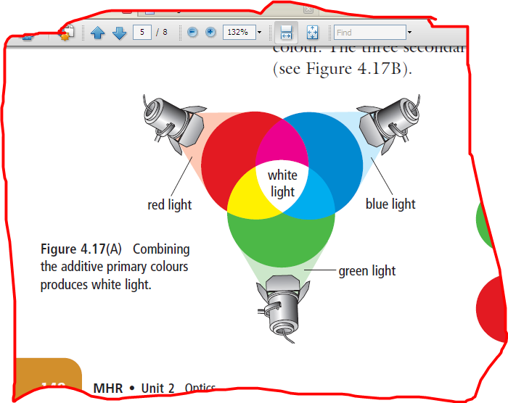They are called the three _______________ ______________ ______________ because adding all three together in proper amounts will make white light.





* + - The light of two additive primary colours will produce a ______________________ ___________.



* + - * The three secondary colours are __________, _________, and ________________.

