**4.1 Properties of Waves** Name:

Date:

Block:

(Refer to BC Science 8 pp. 134 – 143)

Read through Chapter 4.1. Then, by referring to the textbook, answer the following questions.

**DEFINITIONS**

1. Wave: **is a disturbance or movement that transfers energy through matter or space, without causing any permanent displacement**
   1. Examples of waves include: **Sound, light, and ocean waves**
2. Energy**: is the capacity to apply a force over a distance**
   1. Force: **Is a push or pull on an object**

**Features of a Wave**

* crest: **highest point in a wave**
* trough: **lowest point in a wave**
* wavelength: **is the distance from crest to crest or from trough to trough**
  + crest to **crest** or trough to **trough**
* Amplitude: **is the height of a wave crest or depth of a wave through, as measured from its rest position**

 **Label the parts of the wave below.**

**Frequency: is the number of repetitive motions, or oscillations, that occur in a given time**

* What is frequency measured in? **Hertz**

****When the frequency of a wave increases the wavelength **decreases** and vice versa.

* + - Frequency and wavelength have an **inverse** relationship
* Frequency can be calculated using the following equation:

**Frequency = cycles ÷ seconds**

**Use the above equation to find the frequency for each of the following:**

a) A hummingbird flaps its wings 120 times in 3 seconds.

b) A DVD spins 35 times in 7 seconds.

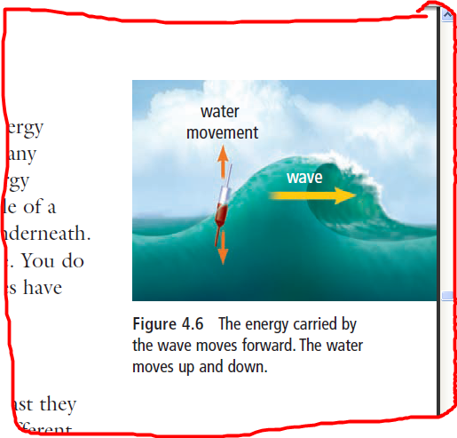

**A WATER WAVE MOVES ENERGY, NOT WATER**

* A water wave does not move **water** along with it.
  + The water molecules only move up and down.
* Only the **energy** carried by the water wave moves forward.

**Two Types of Waves**

* Medium: **matter that waves travel through**
* 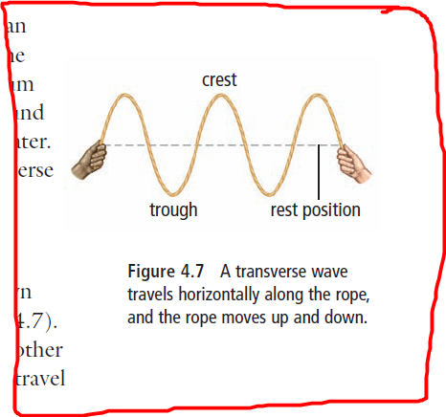The medium can be **solid, liquid or gas.**
* Some waves, such as **visible light and radio** waves, can travel through space where there is no medium.
* Two types of waves that travel through a medium are:
  + 1. 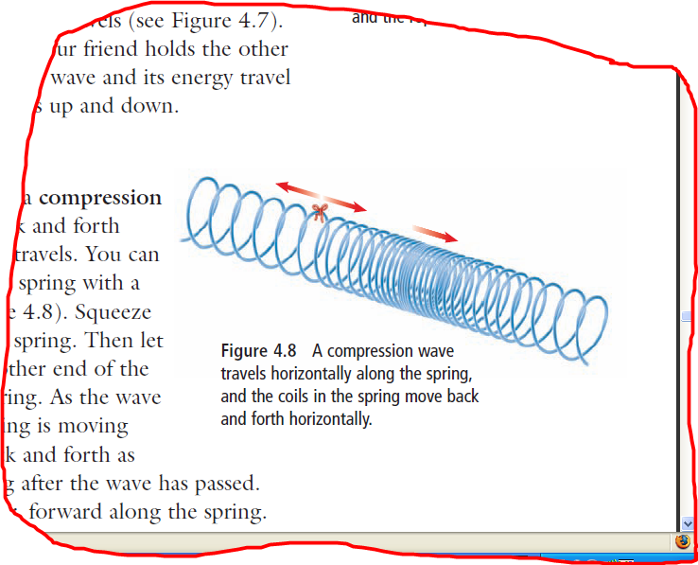**Transverse waves**: **matter in the medium moves up and down perpendicular to the direction that the wave travels**
* For example: **Shaking a rope up and down**
  + 1. **Compression waves**: **matter in the medium moves back and forth along the same direction that the wave travels**
       - For example: **compression and expansion of a coil or spring**
* Water waves and seismic (earthquake) waves are a combination of **transverse and compression** waves.