**4.1 Properties of Waves** Name:

Date:

Block:

(Refer to BC Science 8 pp. 134 – 143)

Read through Chapter 4.1. Then, by referring to the textbook, answer the following questions.

**DEFINITIONS**

1. Wave: _________________________________________________________ ______________________________________________________________
   1. Examples of waves include: ____________________________________ _________________________________________________________
2. Energy: ________________________________________________________
   1. Force: ____________________________________________________

**Features of a Wave**

* crest: ___________________________________________________________
* trough: __________________________________________________________
* wavelength: ____________________________________________________________
  + crest to ____________ or trough to _________
* Amplitude: ______________________________________________________________ _______________________________________________________________________

 **Label the parts of the wave below.**

**Frequency:** ___________________________________________________________________ _____________________________________________________________________________

* What is frequency measured in?

****When the frequency of a wave increases the wavelength ________________ and vice versa.

* + - Frequency and wavelength have an

****_____________ relationship

* Frequency can be calculated using the following equation:

**_________________ = ______________ ÷ ________________**

**Use the above equation to find the frequency for each of the following:**

a) A hummingbird flaps its wings 120 times in 3 seconds.

b) A DVD spins 35 times in 7 seconds.

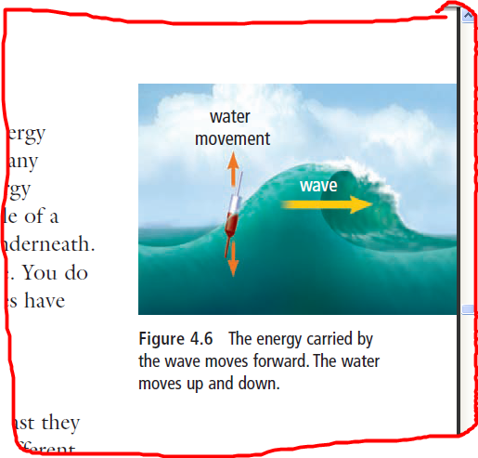

**A WATER WAVE MOVES ENERGY, NOT WATER**

* A water wave does not move __________ along with it.
  + The water molecules only move up and down.
* Only the ___________ carried by the water wave moves forward.

**Two Types of Waves**

* Medium: _______________________________________________________
* 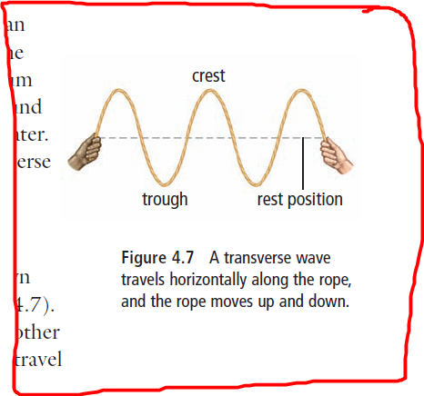The medium can be _______, __________ or _____.
* Some waves, such as ________ waves, can travel through space where there is no medium.
* Two types of waves that travel through a medium are:
  + 1. 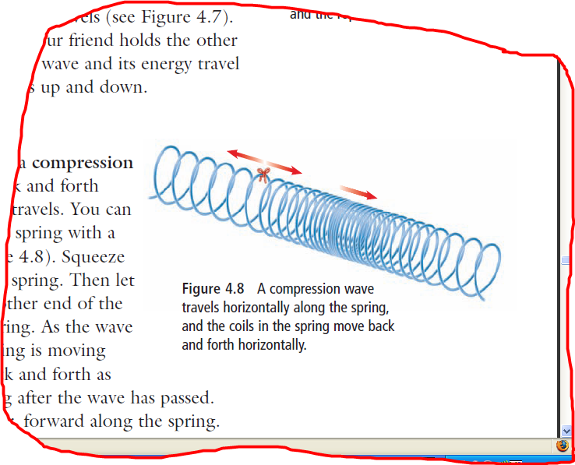**Transverse waves**: ________________________ ________________________________________
* For example: __________________________________
  + 1. **Compression waves**: ________________________ ________________________________________
       - For example: __________________________________
* Water waves and seismic (earthquake) waves are a combination of _________________ and ______________________ waves.