3.1 The Immune System
(refer to pg. 100 – 114)
*Complete Activity 3-1: Pass it on
1) Explain how this activity demonstrates how an infection disease is transmitted
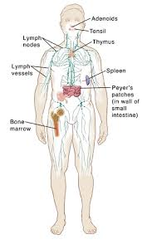

- Immune system: the system that defends the body against _____________________ and _____________________________ substances such as bacteria, viruses and cancer cells.
- Pathogens (disease causing invaders) can infect people with a range of ________________________ diseases

Parts of the Immune System
Structure | Function
Lymph Nodes | Small bean shaped structures that _________________ and ________________________cells that fight infection
Lymph vessels | Vessels that connect the different parts of the immune system
Spleen | Stores _______________________________________ that fight disease and infection
Bone Marrow | Tissue in the center of the bone that produce ____________________________________________

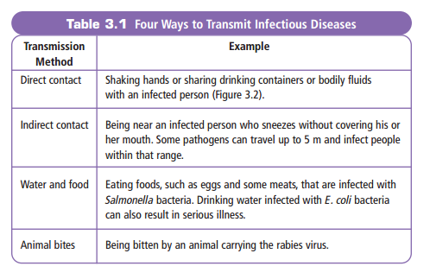
How can infectious diseases be passed on?

Our immune system has two lines of defense:
First Line of Defence
- ___________________: a physical barrier that stops pathogens from entering the body
- Sweat and oil: slightly __________________________ which prevents pathogens from growing on the surface of your body
- Gastric juice: acid secreted by the _________________________which kills bacteria that enter
- Mucus and cilia: line nose and prevent pathogens from entering your respiratory system

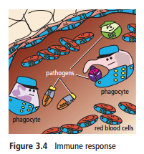
Second Line of Defence
- If a pathogen makes it past the first line of defence your body will attack and destroy the invader
  - Imagine each of your cells wears a ___________________
  - Your immune system recognizes the uniforms of unknown cells and attacks them

- There are two types of immune responses:

1) Innate immune response: the response you are born with
    - Quick, general and _____________________________
    - Used against bacteria and some viruses
    - First step is ________________________ which is the flow of fluid and cells to the site of infection. This causes a fever, swelling and redness.
    - Increase in white blood cells called _________________________which eat up the invaders.

2) Acquired immune response: highly specific attack on a particular pathogen or antigen
    - Antigen: an non-living particle the body cannot recognize, from a virus to a splinter
    - Uses two special types of white blood cells: ____________________ and ___________________________
    - B Cells: recognize the antigens and produce _______________________ to fight them
    - Helper T Cells: recognizes an antigen and activates B Cells
    - Killer T Cell: Directly destroy _____________________
  - Once the attack is over some antibodies stay in the body to protect against future infections, we call this _____________________________

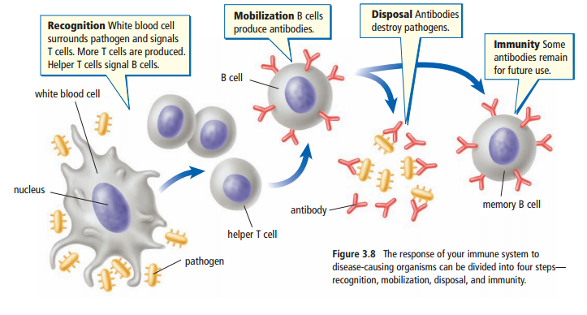

Watch this video on the immune system https://goo.gl/6uNxtp
3.2 Factors Affecting the Immune System
Vaccine: special version of an antigen that gives you __________________________ against a disease.
- Stimulate the immune system to create the ________________________ against that disease
Immune System Disorders
Allergy: an unusually high sensitivity to a substance, which causes an immune reaction.
- Allergy symptoms are caused by the release of ______________________ which is a chemical that your body release when it is fighting invaders.
Acquired Immunodeficiency Syndrome (AIDS)
- Caused by Human Immunodeficiency Virus (HIV), a ____________________ that attack the immune system and infects helper _________________________.
- The body can no longer activate B or killer T cells to destroy the antigen or pathogen

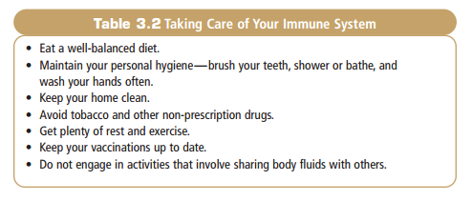
*Complete pages 40, 42 – 43 of section 3.1 and page 46, 47 and 49 of section 3.2 in your workbook

