**3.1 Compounds** Name:

Date:

(Use pages 76 to 80 of BC Science 9 to fill in the blanks.)

* **compound**: \_\_\_\_\_\_\_\_\_\_\_\_\_\_\_\_\_\_\_\_\_\_\_\_\_\_\_\_\_\_\_\_\_\_\_\_\_\_\_\_\_\_\_\_\_\_\_\_\_\_

\_\_\_\_\_\_\_\_\_\_\_\_\_\_\_\_\_\_\_\_\_\_\_\_\_\_\_\_\_\_\_\_\_\_\_\_\_\_\_\_\_\_\_\_\_\_\_\_\_\_\_\_\_\_\_\_\_\_\_\_\_\_\_\_\_\_\_\_\_\_\_\_\_\_\_\_\_\_\_\_\_\_\_\_\_\_\_\_\_\_\_\_\_\_\_\_\_\_\_\_\_\_\_\_\_\_\_\_\_\_\_\_\_\_\_\_\_\_\_\_

* + 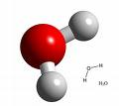Ex. water -> \_\_\_\_\_\_\_\_ and salt (sodium chloride) -> \_\_\_\_\_\_\_\_\_\_\_

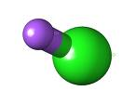

* Compounds form when atoms are held together by chemical bonds.
* **chemical bonds**:\_\_\_\_\_\_\_\_\_\_\_\_\_\_\_\_\_\_\_\_\_\_\_\_\_\_\_\_\_\_\_\_\_\_\_\_\_\_\_\_\_\_\_\_\_\_\_\_\_\_\_\_\_\_\_\_\_\_\_\_\_\_\_\_ \_\_\_\_\_\_\_\_\_\_\_\_\_\_\_\_\_\_\_\_\_\_\_\_\_\_\_\_\_\_\_\_\_\_\_\_\_\_\_\_\_\_\_\_\_\_\_\_\_\_\_\_\_\_\_\_\_\_\_\_\_\_\_\_\_\_\_\_\_\_\_\_\_\_\_\_\_\_
* There are two types of chemical bonds that result in two basic types of compounds:

|  |  |
| --- | --- |
| Type of Bond | Results In What Type of Compound? |
| 1. **covalent bonds**: links between two or more atoms due the \_\_\_\_\_\_\_\_\_\_\_\_\_\_\_\_\_ of electrons |  |
| 1. **ionic bonds**: links between two or more atoms due to the attraction between oppositely charged ions formed by the \_\_\_\_\_\_\_\_\_\_\_\_\_\_\_\_\_ of electrons. |  |

**Covalent Compounds**

**Covalent compounds**\_\_\_\_\_\_\_\_\_\_\_\_\_\_\_\_\_\_\_\_\_\_\_\_\_\_\_\_\_\_\_\_\_\_\_\_\_\_\_\_\_\_\_\_\_\_\_\_\_\_\_\_\_\_\_\_\_

\_\_\_\_\_\_\_\_\_\_\_\_\_\_\_\_\_\_\_\_\_\_\_\_\_\_\_\_\_\_\_\_\_\_\_\_\_\_\_\_\_\_\_\_\_\_\_\_\_\_\_\_\_\_\_\_\_\_\_\_\_\_\_\_\_\_\_\_\_\_\_\_\_\_\_

Contain non-metal atoms \_\_\_\_\_\_\_\_\_\_\_ electrons with other non-metal atoms.

the shared pairs of electrons form \_\_\_\_\_\_\_\_\_\_\_\_\_ bonds that keep the atoms together.

Ex. \_\_\_\_\_\_\_\_\_\_\_ \_\_\_\_\_\_\_\_\_\_\_\_\_\_\_\_ and \_\_\_\_\_\_\_\_\_

|  |  |
| --- | --- |
| **Number** | **Prefix** |
| 1 |  |
| 2 |  |
| 3 |  |
| 4 |  |
| 5 |  |
| 6 |  |
| 7 |  |
| 8 |  |
| 9 |  |
| 10 |  |

* + - * The chemical names of covalent compounds use prefixes. (Not in the text, but which ones do you know? Fill in the table to on the left.)
      * the smallest possible particle of water is a single \_\_\_\_\_\_\_\_\_\_.
      * **molecule**: \_\_\_\_\_\_\_\_\_\_\_\_\_\_\_\_\_\_\_\_\_\_\_\_\_\_\_\_\_\_\_\_\_\_\_\_\_\_\_\_\_\_\_\_\_ \_\_\_\_\_\_\_\_\_\_\_\_\_\_\_\_\_\_\_\_\_\_\_\_\_\_\_\_\_\_\_\_\_\_\_\_\_\_\_\_\_\_\_\_\_\_\_\_\_\_\_\_\_\_\_\_\_\_\_\_\_\_
* a water molecule is composed of two \_\_\_\_\_\_\_\_\_\_\_\_ atoms and one \_\_\_\_\_\_\_\_\_\_\_\_ atom.
* the formula for water is \_\_\_\_\_\_\_ .
* 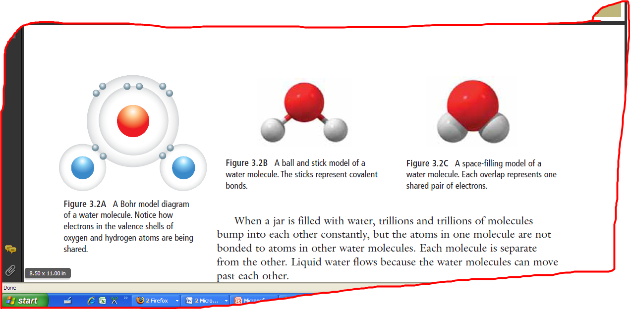Below are 3 common ways of modeling a water molecule





**Ionic Compounds**

**Ionic compounds**: \_\_\_\_\_\_\_\_\_\_\_\_\_\_\_\_\_\_\_\_\_\_\_\_\_\_\_\_\_\_\_\_\_\_\_\_\_\_\_\_\_\_\_\_\_\_\_\_\_\_\_\_\_\_\_\_\_\_\_ \_\_\_\_\_\_\_\_\_\_\_\_\_\_\_\_\_\_\_\_\_\_\_\_\_\_\_\_\_\_\_\_\_\_\_\_\_\_\_\_\_\_\_\_\_\_\_\_\_\_\_\_\_\_\_\_\_\_\_\_\_\_\_\_\_\_\_\_\_\_\_\_\_\_

* + - * + Ex. table salt is made from elements \_\_\_\_\_\_\_\_\_\_\_ and \_\_\_\_\_\_\_\_\_\_\_\_\_\_
        + the formula for table salt is \_\_\_\_\_\_\_\_\_\_

|  |  |
| --- | --- |
| clip_image002 | * when the atoms of each element get close enough together, an \_\_\_\_\_\_\_\_\_\_\_\_\_\_\_ transfers from the sodium to the chlorine, making a \_\_\_\_\_\_\_\_\_\_\_\_\_ sodium ion, Na+, and a \_\_\_\_\_\_\_\_\_\_\_\_\_\_ chloride ion, Cl-. * An ionic compound forms when an electron on a \_\_\_\_\_\_\_\_\_ atom transfers to a \_\_\_\_\_\_-\_\_\_\_\_\_\_\_\_ atom, creating \_\_\_\_\_\_\_\_\_\_\_\_\_\_ charged ions. |

* + - * + when the atoms of each element first come together, both are electrically \_\_\_\_\_\_\_\_\_\_\_\_\_\_\_\_.
* ionic compounds are \_\_\_\_\_\_\_\_\_\_\_\_\_\_\_\_ because positive charges and negative charges balance.

|  |  |
| --- | --- |
| Draw an ionic lattice here: | **ionic lattice**: \_\_\_\_\_\_\_\_\_\_\_\_\_\_\_\_\_\_\_\_\_\_\_\_\_\_\_\_\_\_\_\_\_\_\_  \_\_\_\_\_\_\_\_\_\_\_\_\_\_\_\_\_\_\_\_\_\_\_\_\_\_\_\_\_\_\_\_\_\_\_\_\_\_\_\_\_\_\_\_\_  \_\_\_\_\_\_\_\_\_\_\_\_\_\_\_\_\_\_\_\_\_\_\_\_\_\_\_\_\_\_\_\_\_\_\_\_\_\_\_\_\_\_\_\_\_\_\_  \_\_\_\_\_\_\_\_\_\_\_\_\_\_\_\_\_\_\_\_\_\_\_\_\_\_\_\_\_\_\_\_\_\_\_\_\_\_\_\_\_\_\_\_\_\_\_  \_\_\_\_\_\_\_\_\_\_\_\_\_\_\_\_\_\_\_\_\_\_\_\_\_\_\_\_\_\_\_\_\_\_\_\_\_\_\_\_\_\_\_\_\_\_\_  \_\_\_\_\_\_\_\_\_\_\_\_\_\_\_\_\_\_\_\_\_\_\_\_\_\_\_\_\_\_\_\_\_\_\_\_\_\_\_\_\_\_\_\_\_\_\_ |

**Molecules, Ions, and Polyatomic Ions**

* + **polyatomic ion**: \_\_\_\_\_\_\_\_\_\_\_\_\_\_\_\_\_\_\_\_\_\_\_\_\_\_\_\_\_\_\_\_\_\_\_

\_\_\_\_\_\_\_\_\_\_\_\_\_\_\_\_\_\_\_\_\_\_\_\_\_\_\_\_\_\_\_\_\_\_\_\_\_\_\_\_\_\_\_\_\_\_\_.

* + - * + has a charge so considered an ion.
        + the prefix "poly-" means \_\_\_\_\_\_\_\_\_\_\_
        + Ex. The dichromate ion has the formula \_\_\_\_\_\_\_\_\_\_\_\_

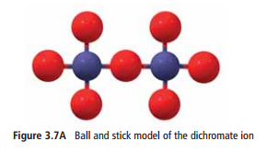made up of two atoms of \_\_\_\_\_\_\_\_\_\_\_\_ and seven atoms of \_\_\_\_\_\_\_\_\_\_\_\_ which are held together by \_\_\_\_\_\_\_\_\_\_\_\_ \_\_\_\_\_\_\_\_

has a charge of \_\_\_\_\_ which enables it to connect to positive potassium ions by \_\_\_\_\_\_\_\_ \_\_\_\_\_\_\_

* Polyatomic ions are an important part of many materials.

Examples include:

carbonate ( \_\_\_\_\_\_\_\_), helps form \_\_\_\_\_\_\_\_\_\_\_\_\_\_\_\_\_\_\_\_\_\_\_\_\_\_\_\_\_\_\_\_\_\_\_\_\_\_\_\_\_\_\_\_\_\_\_\_\_\_\_\_\_\_\_\_\_\_\_\_\_\_\_\_\_\_

phosphate (\_\_\_\_\_\_\_\_), is a major component of \_\_\_\_\_\_\_\_\_\_\_\_\_\_\_\_\_\_\_\_\_\_\_\_\_\_\_\_\_\_\_\_\_\_\_\_\_\_\_\_\_\_\_\_\_\_\_\_\_\_\_\_\_\_\_\_\_\_\_\_\_\_\_\_\_\_

ammonium nitrate is composed of \_\_\_\_ polyatomic ions: ammonium (\_\_\_\_\_\_\_\_) and nitrate (\_\_\_\_\_\_\_\_). It is an important \_\_\_\_\_\_\_\_\_\_\_\_\_\_\_\_\_\_\_\_\_\_\_\_\_\_\_\_\_\_\_\_\_\_\_\_\_\_\_\_

Find your own example of a polyatomic ion and how they are used in a material!

|  |  |
| --- | --- |
| Polyatomic Ion: | Explanation of Use in Material: |

**Ionic and Covalent Compounds** *- Summary*  Name:

Date:

Block:

In the diagrams below…

1. **Label** each **type of compound** as either ionic or covalent.
2. **Draw arrows** and **label** all **ionic** and **covalent bonds**. (Hint: there are 11 bonds in total).
3. **Label** each **nucleus** with the **appropriate element symbol.**

|  |  |  |
| --- | --- | --- |
| **Water (H2O)**    **Type of compound:**  **\_\_\_\_\_\_\_\_\_\_\_\_\_\_\_\_\_\_**  **Type of bond(s):**  **\_\_\_\_\_\_\_\_\_\_\_\_\_\_\_\_\_\_ \_\_\_\_\_\_\_\_\_\_\_\_\_\_\_\_\_\_** |  |  |
| **sodium chloride (NaCl)**    **Type of compound:**  **\_\_\_\_\_\_\_\_\_\_\_\_\_\_\_\_\_\_**  **Type of bond(s):**  **\_\_\_\_\_\_\_\_\_\_\_\_\_\_\_\_\_\_**  **\_\_\_\_\_\_\_\_\_\_\_\_\_\_\_\_\_\_** |  | |
| **ammonium nitrate**  **(NH4NO3)**    **Type of compound:**  **\_\_\_\_\_\_\_\_\_\_\_\_\_\_\_\_\_\_**  **Type of bond(s):**  **\_\_\_\_\_\_\_\_\_\_\_\_\_\_\_\_\_\_**  **\_\_\_\_\_\_\_\_\_\_\_\_\_\_\_\_\_\_** |  | |