**3.1 Compounds** Name:

Date:

(Use pages 76 to 80 of BC Science 9 to fill in the blanks.)

* **compound**: a pure substance made of more than one kind of element that have been chemically combined
  + 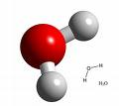Ex. water -> H2O and salt (sodium chloride) -> NaCl

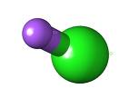

* Compounds form when atoms are held together by chemical bonds.
* **chemical bonds**: links between two or more atoms that hold the atoms together
* There are two types of chemical bonds:

|  |  |
| --- | --- |
| Type of Bond | Results In What Type of Compound? |
| 1. **covalent bonds**: links between two or more atoms due the SHARING of electrons | COVALENT COMPOUND |
| 1. **ionic bonds**: links between two or more atoms due to the attraction between oppositely charged ions formed by the TRANSFERRING of electrons. | IONIC COMPOUND |

**Covalent Compounds**

**Covalent compounds**: compounds in which atoms combine by sharing electrons to form molecules

Contain non-metal atoms sharing electrons with other non-metal atoms.

the shared pairs of electrons form covalent bonds that keep the atoms together.

Ex. Carbon dioxide and water

|  |  |
| --- | --- |
| **Number** | **Prefix** |
| 1 | mono |
| 2 | di |
| 3 | tri |
| 4 | tetra |
| 5 | penta |
| 6 | hexa |
| 7 | hepta |
| 8 | octa |
| 9 | nona |
| 10 | deca |

* + - * The chemical names of covalent compounds use prefixes. (Not in the text, but which ones do you know? Fill in the table to on the left.)
      * the smallest possible particle of water is a single molecule.
      * **molecule**: a group of atoms in which the atoms are bound together by sharing of electrons
* a water molecule is composed of two hydrogen atoms and one oxygen atom.
* the formula for water is H2O .
* 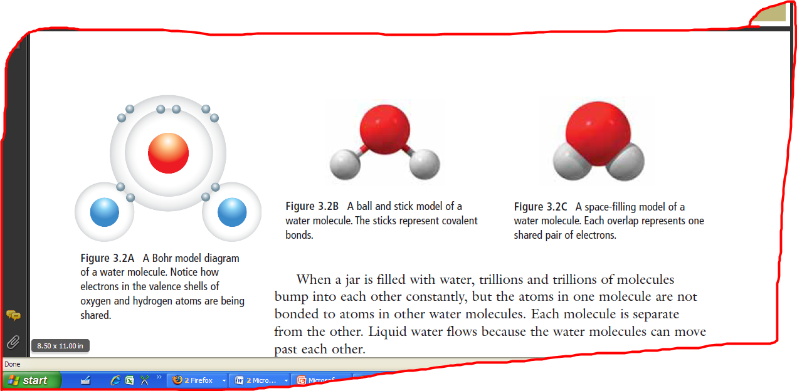Below are 3 common ways of modeling a water molecule





**Ionic Compounds**

**Ionic compounds**: compounds in which atoms gain or lose (transfer) electrons to form oppositely charged ions which are attracted to each other

* + - * + Ex. table salt is made from elements sodium and chloride
        + the formula for table salt is NaCl

|  |  |
| --- | --- |
| clip_image002 | * when the atoms of each element get close enough together, an electron transfers from the sodium to the chlorine, making a positive sodium ion, Na+, and a negative chloride ion, Cl-. * An ionic compound forms when an electron on a metal atom transfers to a non-metal atom, creating oppositely charged ions. |

* + - * + when the atoms of each element first come together, both are electrically neutral
* ionic compounds are neutral because positive charges and negative charges balance.

|  |  |
| --- | --- |
| Draw an ionic lattice here:  clip_image003 | **ionic lattice**: a repeating pattern of positive and negative ions forming an ionic compound |

**Molecules, Ions, and Polyatomic Ions**

* + **polyatomic ion**: a molecular ion composed of more than one type of atom joined by covalent bonds
    - * + has a charge so considered an ion.
        + the prefix "poly-" means many
        + Ex. The dichromate ion has the formula Cr2O72-

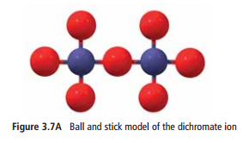made up of two atoms of chromium and seven atoms of oxygen which are held together by covalent bonds

has a charge of 2- which enables it to connect to positive potassium ions by ionic bonds

* Polyatomic ions are an important part of many materials.

Examples include:

carbonate ( CO32-) helps form egg shells, tooth enamel

phosphate (PO43-) is a major component of your bones and teeth

ammonium nitrate is composed of 2 polyatomic ions: ammonium (NH4+) and nitrate (NO3-). It is an important fertilizer in the world

Find your own example of a polyatomic ion and how they are used in a material!

|  |  |
| --- | --- |
| Polyatomic Ion:  Can look for examples on sheet | Explanation of Use in Material:  Student generated, online search |

**Ionic and Covalent Compounds** *- Summary*  Name:

Date:

Block:

In the diagrams below…

1. **Label** each **type of compound** as either ionic or covalent.
2. **Draw arrows** and **label** all **ionic** and **covalent bonds**. (Hint: there are 11 bonds in total).
3. **Label** each **nucleus** with the **appropriate element symbol.**

|  |  |  |
| --- | --- | --- |
| **Water (H2O)**    **Type of compound:**  **Covalent**  **Type of bond(s):**  **Covalent** |  |  |
| **sodium chloride (NaCl)**    **Type of compound:**  **Ionic**  **Type of bond(s):**  **Ionic** |  | |
| **ammonium nitrate**  **(NH4NO3)**    **Type of compound:**  **Ionic**  **Type of bond(s):**  **Covalent**  **Ionic** |  | |