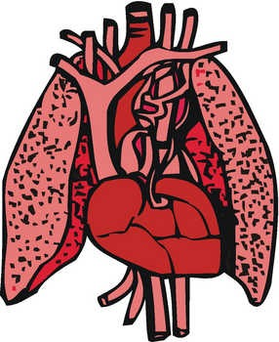**2.3 THE CIRCULATORY AND RESPIRATORY Systems**

**Name:**

**Date:**

**Block:**

**The Respiratory System**

* **respiratory system**: the body system that supplies blood with _____________ and removes ___________ ____________ from the blood.
* The two **__________** are important organs in this system
  + - They bring in oxygen for _____________ _________________
    - They ______________ carbon dioxide.
* __________________ is the process that brings oxygen into your nose or mouth.
* When you inhale, air is filtered by tiny hairs called __________.
  + - Cilia and mucus _______ dirt and other particles.
    - 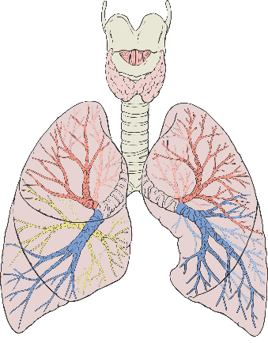The particles are either pushed back out the _____________ or flushed down into the _________________ system.
* Air passes through your **_________** (voice box) and continues down your **__________** towards your lungs.
* At the base of the trachea are two tubes called **________________**.
* Bronchi branch into smaller air tubes called **_____________________**.
* 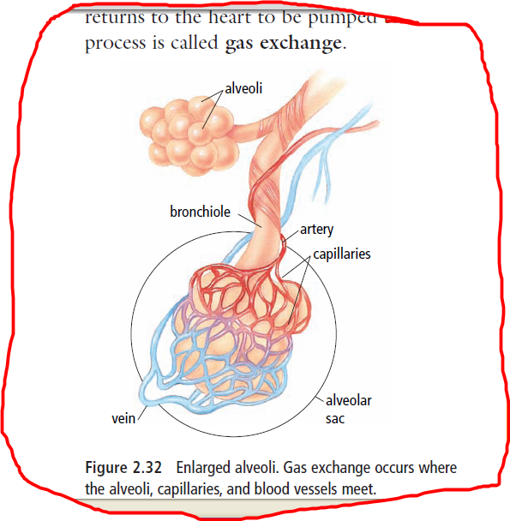Finally, the air reaches tiny, thin-walled sacs called **_____________**.

**Gas Exchange in the Alveoli**

* There are millions of alveoli at the ends of the bronchioles, and this is where **______ _______________** takes place.
  + - 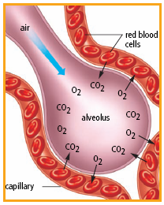Oxygen and carbon dioxide move back and forth between the __________ and the surrounding _________ ______________.



**Smoking**

* Smoking may cause both _______________ disease and ____________ disease.
* Respiratory diseases could include _______________ and ________ ____________.
  + Emphysema causes the alveoli walls to lose their _______________. This may make breathing very difficult.
* Smoking also destroys the _________ ____________ in your respiratory system.