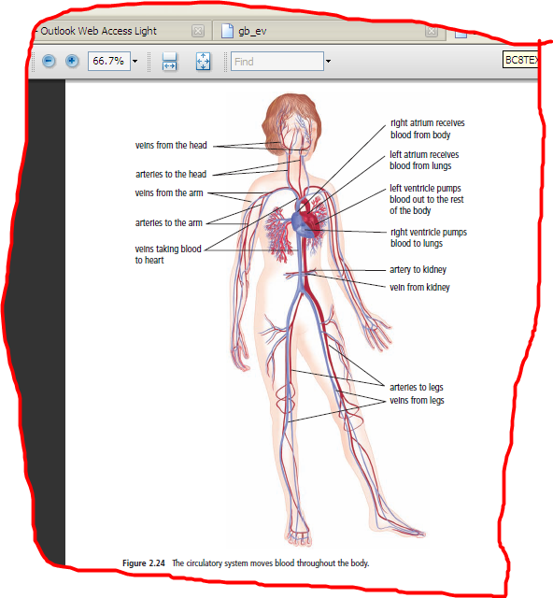

**2.3 THE CIRCULATORY SYSTEM**

**(Refer to pp. 82 – 89 of BC Science 8) Name:**

**Date:**

* **circulatory system**: the body system that moves blood through the body.
* Your heart is a pump that pushes approximately 4 L of blood through your body every minute.

**THE CIRCULATORY SYSTEM**

* The circulatory system includes the heart, blood vessels and blood.
* It is like a large highway system.
  + - The blood vessels are like the roads and the blood is like the cars.
* 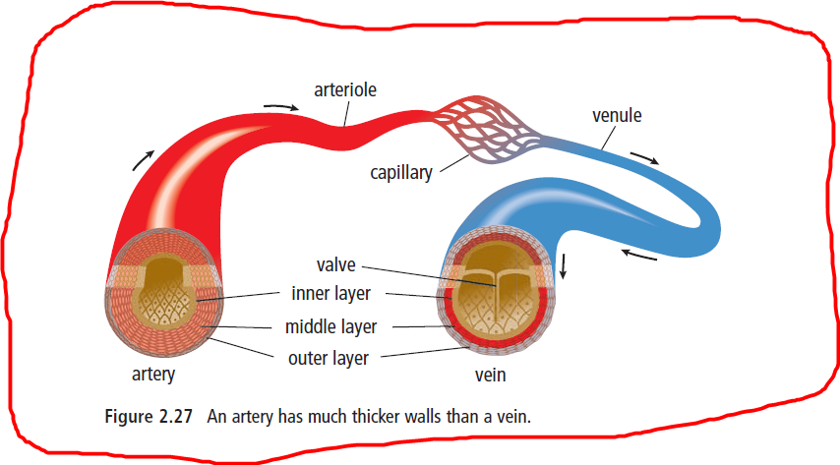**Blood vessels:** a network of road that carry blood through your body.

**TYPES OF BLOOD VESSELS**

There are 3 types of blood vessels: <https://goo.gl/oCaK6S>

|  |  |  |  |
| --- | --- | --- | --- |
|  | **Arteries** | **Capillaries** | **Veins** |
| **Definition** | * carry oxygenated blood AWAY from the heart. | * a network of tiny blood vessels that connect arterioles to venules. | * blood vessels that carry deoxygenated blood back to the heart |
| **Characteristics** | * Have THICK walls * Blood in the arteries is bright red because it is rich in oxygen | * Have very thin walls. * Are responsible for the diffusion (transfer) of oxygen and nutrients into the body cells and wastes out of the body cells. | * Have THIN walls. * Have VALVES that prevent the backflow of blood. * Contain waste products returning to the heart. * Blood is thicker and darker in colour. |
| **Special Names** | * The largest artery is the **AORTA** * The smallest arteries are called **arteriole** |  | * The largest vein is the **vena cava** * The smallest veins are called **venules** |

**TAKING A CLOSER LOOK AT THE HEART*:*** *Interactive Heart*: <http://goo.gl/IhNrjJ>*Bill Nye:* <https://goo.gl/GUC7iZ>

|  |
| --- |
| * The heart is a muscular organ that pumps blood throughout the body. * It has 4 chambers: two upper atria chambers and two lower ventricle chambers. * The **atria** allow the blood to move into the heart. * The **ventricles** pump blood out of the heart. * Between the right atrium and right ventricle, and the left atrium and left ventricle are valves, which allow blood to flow in only one direction (from atrium to ventricle). |

**HOW BLOOD MOVES THROUGH THE HEART**:

**Place the following structures in the correct order that blood flows through the body.**

* + - Left Atrium, Right Atrium, Left Ventricle, Right ventricle, Body, Lungs



**THE COMPONENTS OF BLOOD**

**FUNCTIONS AND COMPONENTS OF BLOOD**

* Blood transports oxygen, nutrients and water to your cells and carries carbon dioxide and wastes away from your cells.
* Blood also carries specialized cells to help fight infections and heal wounds
* There are 4 components of blood:
  1. PLASMA contains water, proteins and minerals
  2. RED BLOOD CELLS carries oxygen and carbon dioxide
  3. WHITE BLOOD CELLS fight infections
  4. PLATELETS important for clotting blood to heal wounds.
* Bill Nye on the Heart: <https://goo.gl/f80hdv>