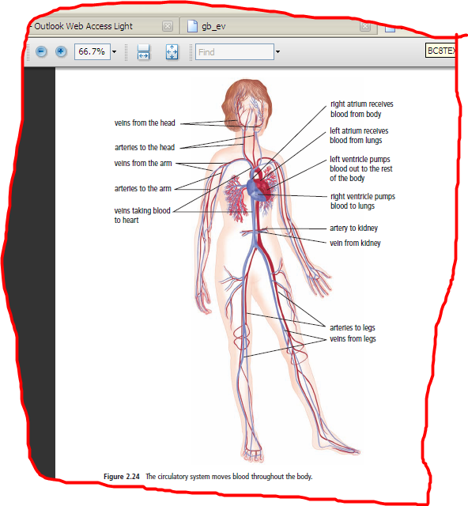

**2.3 THE CIRCULATORY SYSTEM**

**(Refer to pp. 82 – 89 of BC Science 8) Name:**

**Date:**

* **circulatory system**: the body system that moves ________ through the body.
* Your heart is a pump that pushes approximately 4 L of blood through your body every minute.

**THE CIRCULATORY SYSTEM**

* The circulatory system includes the heart, blood vessels and blood.
* It is like a large ____________ system.
  + - The _________ ___________ are like the roads and the _________ is like the cars.
* 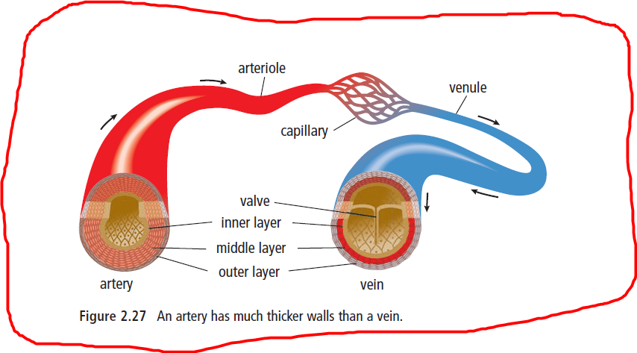**Blood vessels:** a network of ________ that carry blood through your body.

**TYPES OF BLOOD VESSELS**

There are 3 types of blood vessels: <https://goo.gl/oCaK6S>

|  |  |  |  |
| --- | --- | --- | --- |
|  | **Arteries** | **Capillaries** | **Veins** |
| **Definition** | * carry oxygenated blood _________ from the heart. | * a network of tiny blood vessels that ___________ arterioles to venules. | * blood vessels that carry deoxygenated blood ______ ____ the heart |
| **Characteristics** | * Have ________ walls * Blood in the arteries is bright red because it is rich in ___________. | * Have very _______ walls. * Are responsible for the ____________ of oxygen and nutrients into the body cells and wastes out of the body cells. | * Have _______ walls. * Have _________ that prevent the backflow of blood. * Contain ________ products returning to the heart. * Blood is thicker and darker in colour. |
| **Special Names** | * The largest artery is the **__________**. * The smallest arteries are called **_______________**. |  | * The largest vein is the **______ ______**. * The smallest veins are called **___________**. |

**TAKING A CLOSER LOOK AT THE HEART*:*** *Interactive Heart*: <http://goo.gl/IhNrjJ>*Bill Nye:* <https://goo.gl/GUC7iZ>

|  |
| --- |
| * The ___________ is a muscular organ that pumps blood throughout the body. * It has 4 chambers: two upper _________ chambers and two lower ______________ chambers. * The _______ allow the blood to move into the heart. * The _______________ pump blood out of the heart. * Between the right atrium and right ventricle, and the left atrium and left ventricle are ___________, which allow blood to flow in only one direction (from atrium to ventricle). |

**HOW BLOOD MOVES THROUGH THE HEART**:

**Place the following structures in the correct order that blood flows through the body.**

* + - Left Atrium, Right Atrium, Left Ventricle, Right ventricle, Body, Lungs



**THE COMPONENTS OF BLOOD**

**FUNCTIONS AND COMPONENTS OF BLOOD**

* Blood transports ____________, ________, and ___________ to your cells and carries ________ ____________ and __________ away from your cells.
* Blood also carries specialized cells to help fight ____________ and heal ___________.
* There are 4 components of blood:
  1. _______________: contains water, proteins and minerals
  2. _______________: carries _____ and _______
  3. _______________: fight _____________________
  4. _______________: important for ___________ blood to heal wounds.

Bill Nye on the Heart: <https://goo.gl/f80hdv>