Name: Date:



**Chemistry: Elements**

**Text pages**: *pgs 42 to 47 (Section 2.1)*

**Purpose:** To learn about elements and their chemical symbols.

* **Elements:** a pure substance that cannot be broken down into simpler substances
  + about 115 occur naturally and are listed on the Periodic Table

**Chemical symbol**s

* Names are based on different languages such as Latin, German and Greek
* **Chemical symbol**: international symbols for each element.
  + represented by one or two letters
    - If only one letter, it is capitalized
    - If two letters, the first is capitalized and the second is lower case.

**A tour of some common elements**

* Elements have a variety of physical and chemical properties.
* **Physical properties**: a characteristic of matter that you can observe or measure.

ex. colour and mass

* **Chemical properties**: a characteristic that describe matter’s ability to react chemically to produce new substances
  + ex**.** flammability

* Most elements are metals, some are non-metals, a few are metalloids.
  + **Metals**: elements that are typically hard, shiny, malleable, ductile and good conductors of heat and electricity.
    - Usually solid at room temperature.
    - Examples: **iron, sodium, mercury, silver**
  + **Non-metals**: elements that are typically not hard, shiny, malleable, ductile, and that are poor conductors of heat and electricity.
    - Usually gas or brittle solids at room temperature.
    - Examples: **hydrogen, oxygen, chlorine**
  + **Metalloids**: elements that share some properties with metalsand some properties withnon-metals
    - Example: **silicon**

Name: Date:



**Chemistry: The Periodic Table & Chemical Properties**

* **Text pages**: *pgs 52 to 59 (Section 2.2)*
* **Purpose:** To learn about elements and their chemical symbols.

# ORIGIN OF THE PERIODIC TABLE

Chemists in the 19th century wished to organize elements. Attempts focused on grouping elements with similar properties. In 1867, Dmitri Mendeleev, a Russian chemist, found patterns in the elements and organized them into a table according to their atomic mass. The resulting table had holes for elements not yet discovered. In 1913, Henry Moseley reorganized the periodic table according to increasing atomic number.

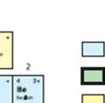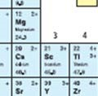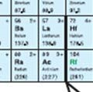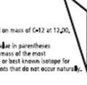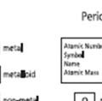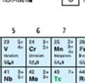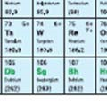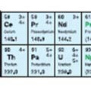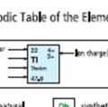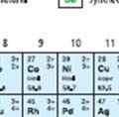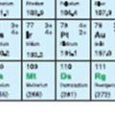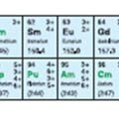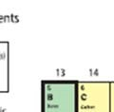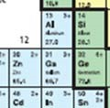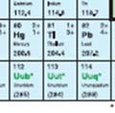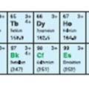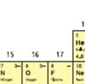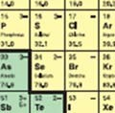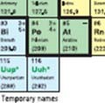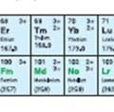

* The Periodic Table gives the following 5 pieces of information for each element:
  1. **atomic number:** # of protons in the nucleus

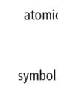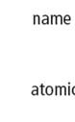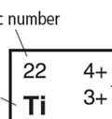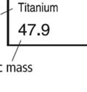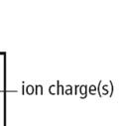

* 1. **Symbol:** one or two letters that represent the element
  2. **Name**: identifies the element.
  3. **Atomic mass:** the average mass of the atoms of an element
  4. **Ion charge:** an electric charge that forms on an atom
* **ion**: an electrically charged atom
  + - **negative ion**: an atom that has gained electrons
      * What group forms negative ions and how? Non-metals form negative ions. It is negative because it has more electrons than protons.
    - **positive ion**: an atom that has lost electrons
      * What group forms negative ions and how? Metals form positive ions. It is positive because it has less electrons than protons

|  |  |
| --- | --- |
| Ex. Oxygen  ATOM ION  8 p+ 8 p+  8 e- 10 e- | Ex. Sodium  ATOM ION  11 p+ 11 p+  11 e- 10 e- |

* **multiple ion charge**: the element can form ions in more than one way

their most common ion charge is the top one on the periodic table.

Ex. Copper

**Metals, Non-metals and Metalloids**

* Elements form 3 groups on the periodic table:
  + - * 1. 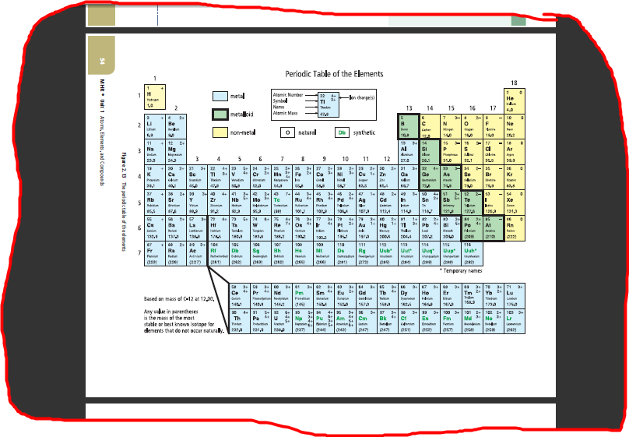**Metals** (left side)
        2. **Non-metals** (all on the right except H)
        3. **Metalloids** (diagonal line like a stair case toward the right side)
        + 8 elements: B, Si, Ge, As, Sb, Te, Po, At

**Periods and Families**

* **period**: horizontal rows in the periodic table

numbered from 1 to 7

* **chemical family** or **group**: vertical columns on the periodic table

elements in the same family have similar physical and chemical properties.

numbered from 1 to 18

Four well-known chemical families/groups:

1. 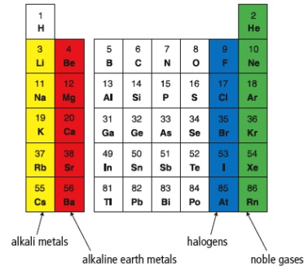**Alkali metals (Group 1):** (Li, Na, K, Rb, Cs, Fr)

* ion charge = 1+
* highly reactive metals
  + - * + reactivity increases as you go down the column
* react with both water and oxygen
* soft; can be cut with a knife

1. **Alkaline earth metals (Group 2):** (Be, Mg, Ca, Sr, Ba, Ra)

* ion charge = 2+
* less reactive than alkali metals.
* will burn in air if heated
* used for fireworks
* react with water

1. **Halogens (Group 17):** (F, Cl, Br, I, At)

* ion charge = 1-
* non-metals
* highly reactive
  + - * + reactivity decreases as you go down the column
        + F and Cl are gases at room temperature, Br is liquid at room temperature and I is solid

1. **Noble gases (Group 18):** (He, Ne, Ar, Kr, Xe, Rn)

* do not form ions, so ion charge = 0
* most stable, unreactive elements
* at room temperature, they are colourless, odorless gases.