Name: Date:



**Chemistry: Elements**

**Text pages**: *pgs 42 to 47 (Section 2.1)*

**Purpose:** To learn about elements and their chemical symbols.

* **Elements:** ______________________________________________________
  + about _____ occur naturally and are listed on the ___________________ ____________

**Chemical symbol**s

* Names are based on different languages such as _________, __________, and ______________.
* **Chemical symbol**: _______________________________**___________________________**.
  + represented by one or two __________________
    - If only one letter, it is _______________.
    - If two letters, the first is _______________, and the second is ________ _______.

**A tour of some common elements**

* Elements have a variety of physical and chemical properties.
* **Physical properties**: _____________________________________________________ _______________________________________________________________________

ex. _____________ and _______________

* **Chemical properties**: _____________________________________________________ _______________________________________________________________________
  + ex**. ____________________________**

* Most elements are metals, some are non-metals, a few are metalloids.
  + **Metals**: elements that are typically ____________, _____________, ______________________, ___________________, and ___________ _______________________ of heat and electricity.
    - Usually ___________ at room temperature.
    - Examples: **iron, sodium, mercury, silver**
  + **Non-metals**: elements that are typically not ___________, _____________________, or ______________, ___________________, and that are ___________ ______________ of heat and electricity.
    - Usually _________ or __________ ___________ at room temperature.
    - Examples: **hydrogen, oxygen, chlorine**
  + **Metalloids**: elements that share some properties with **__________** and some properties with **______-__________**
    - Example: **silicon**

Name: Date:



**Chemistry: The Periodic Table & Chemical Properties**

* **Text pages**: *pgs 52 to 59 (Section 2.2)*
* **Purpose:** To learn about elements and their chemical symbols.

# ORIGIN OF THE PERIODIC TABLE

Chemists in the 19th century wished to ____________ elements. Attempts focused on grouping elements with similar _____________. In 1867, __________ ___________________, a Russian chemist, found _______________ in the elements and organized them into a __________ according to their___________________ ___________. The resulting table had holes for elements not yet ______________. In 1913, ___________ _________ reorganized the periodic table according to increasing _______________ __________________.

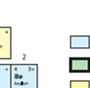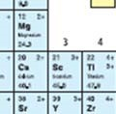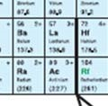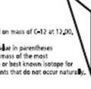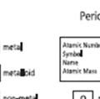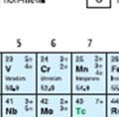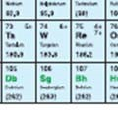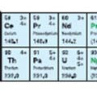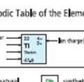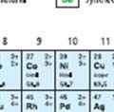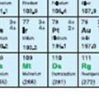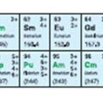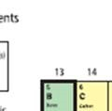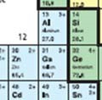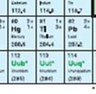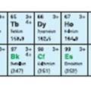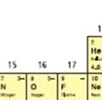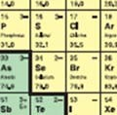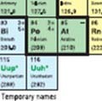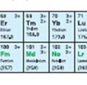

* The Periodic Table gives the following 5 pieces of information for each element:
  1. **___________**_______________________________

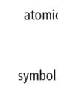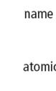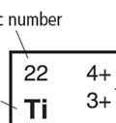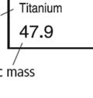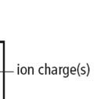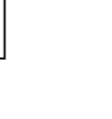

* 1. **__________________________________________**
  2. ___________________________________________
  3. ___________________________________________
  4. ____________________________________________
* **ion**: ___________________________________________________________
  + - **negative ion**: __________________________________________ _______________________________________________________
      * What group forms negative ions and how? _________________________________________________ _________________________________________________

_________________________________________________

_________________________________________________

* + - **positive ion**: ____________________________________________ ______________________________________________________
      * What group forms negative ions and how? _________________________________________________ _________________________________________________

_________________________________________________

_________________________________________________

|  |  |
| --- | --- |
| Ex. Oxygen  ATOM ION  ____ p+ ___ p+  ____ e- ____e- | Ex. Sodium  ATOM ION  ____ p+ ___ p+  ____ e- ____e- |

* **multiple ion charge**: _____________________________________

**____________________________________________________**

their most common ion charge is the _____ one on the periodic table.

Ex. Copper

**Metals, Non-metals and Metalloids**

* Elements form ____ groups on the periodic table:
  + - * 1. 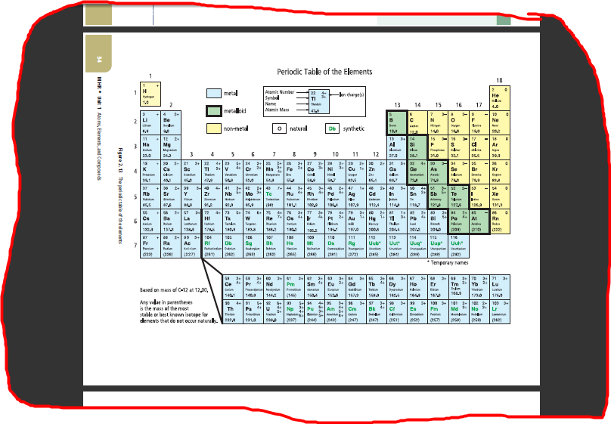**______________** (left side)
        2. **_________________** (all on the right except H)
        3. **_______________** (diagonal line like a stair case toward the right side)
        + 8 elements: B, Si, Ge, As, Sb, Te, Po, At

**Periods and Families**

* **period**: ________________________________________________

numbered from ____ to ____.

* **chemical family** or **group**: __________________________________

elements in the same family have __________ physical and chemical properties.

numbered from ____ to _____.

Four well-known chemical families/groups:

1. 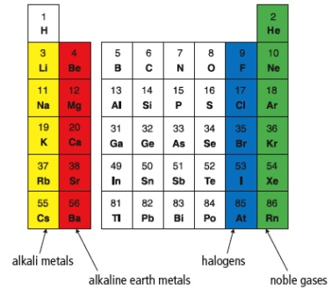**Alkali metals (Group 1):** (Li, Na, K, Rb, Cs, Fr)

* ion charge = _______
* ___________ reactive metals
  + - * + reactivity ________________ as you go down the column
* react with both ____________ and ________________
* __________; can be cut with a knife

1. **Alkaline earth metals (Group 2):** (Be, Mg, Ca, Sr, Ba, Ra)

* ion charge = _______
* ________ reactive than alkali metals.
* will __________ in air if heated
* used for ____________________
* react with ______________

1. **Halogens (Group 17):** (F, Cl, Br, I, At)

* ion charge = _______
* ______-metals
* ____________ reactive
  + - * + reactivity _______________ as you go down the column
        + F and Cl are ___________ at room temperature, Br is __________ at room temperature and I is __________.

1. **Noble gases (Group 18):** (He, Ne, Ar, Kr, Xe, Rn)

* do not form ions, so ion charge = _______
* most ____________, _________________ elements
* at room temperature, they are ____________________, ___________________ gases.