Name:
THE WATER CYCLE, WATER DISTRIBUTION & Sources of Fresh water
Brainstorm with a partner to come up with a flow chart for how a molecule of water in the ocean gets all the way to your kitchen sink.

WATER CYCLE: Watch Video: https://www.youtube.com/watch?v=iohKd5FWZOE There is no audio, so be sure to watch carefully as the sun comes up and heats the land and water, and then goes through the whole water cycle. Be sure to label the arrows on your water cycle diagram. Use the word bank for help.
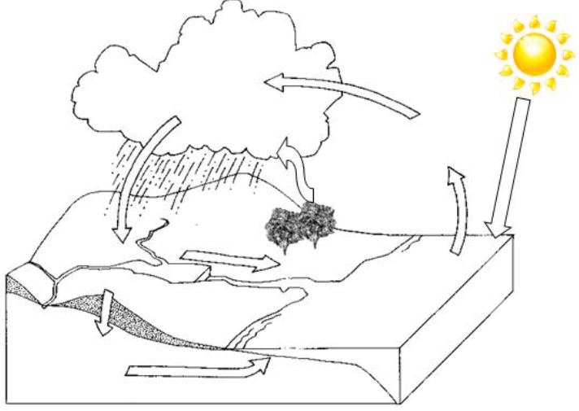

Word Bank – Evaporation, Condensation, Precipitation, Run off, Groundwater Runoff, Transpiration, Infiltration, Solar Radiation.
- Which parts of the water cycle require energy from the sun?
___________________________________________________________________________________________________________________

- Which parts of the water cycle require the water molecules to give away heat energy (cool down)?
___________________________________________________________________________________________________________________

- Which parts of the water cycle are caused by the force of gravity?
___________________________________________________________________________________________________________________
(Refer to pp. 362 – 367 of BC Science 8 – Section 10.1)

WATER DISTRIBUTION
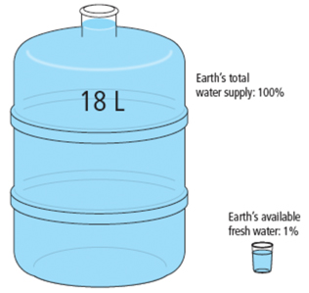
Draw a pie chart to explain the distribution of water on the surface of the Earth:

What is ONE worldwide issue that is related to water: ____________________________________________________________________________________________________________
Why is less than one third of fresh water available to humans?
____________________________________________________________________________________________________________
SOURCES OF FRESH WATER (see pages 376-381 in the BC Science 8 textbook):
- Why is water rolling down a car windshield a good comparison to RUN-OFF?
________________________________________________________________________________________________________________________________________________________________________________________________________________________________________

- Name three factors for why run-off would be higher on the North Shore than the Fraser Valley.
________________________________________________________________________________________________________________________________________________________________________________________________________________________________________

- Why is a watershed also known as a drainage basin?
________________________________________________________________________________________________________________________________________________________________________________________________________________________________________
