2.3 The Periodic Table and Atomic Theory
(Refer to pp. 64 – 71 of BC Science 9) Name:
Date:
Block:
How Atoms Become Ions
        - Atoms try to get to the level of stability of noble gases by LOSING or GAINING electrons.
- Atoms of metals lose e⁻ to form POSITIVE ions.
- Atoms of non-metals gain e⁻ to form NEGATIVE ions.
- Ion charge shown on the symbol by a superscript number followed by a + or - sign.
          - Equal to the SUM of charges of its protons and electrons.

BOHR MODEL DIAGRAMS
- a diagram that shows how many ELECTRONS are in each region (aka ELECTRON SHELLS) surrounding the nucleus.
- Each shell can only hold a CERTAIN NUMBER of electrons.
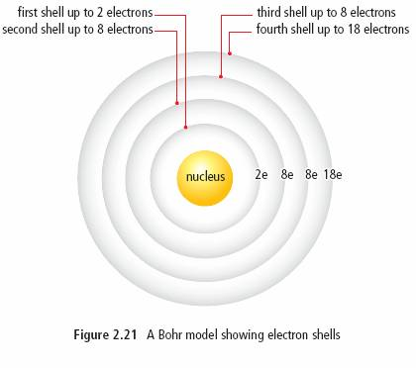
Shell # | # of electrons
1st Shell | 2
2nd Shell | 8
3rd Shell | 8
4th Shell | 18

Three ways that the Bohr model for a potassium atom can be drawn:

Bohr model diagrams usually include:
- The element SYMBOL.
- The number of PROTONS in the nucleus.
- The number of NEUTRONS in the nucleus.
- The number of ELECTRONS and where they are located (on which SHELLS they are located) around the nucleus.
YOUR TURN!
Draw the following Bohr Model Diagrams
Sodium | Fluorine

PATTERNS IN THE PERIODIC TABLE
- Atomic numbers increase by ONE .
- Atomic MASS tends to increase along with the atomic number, with some EXCEPTIONS.
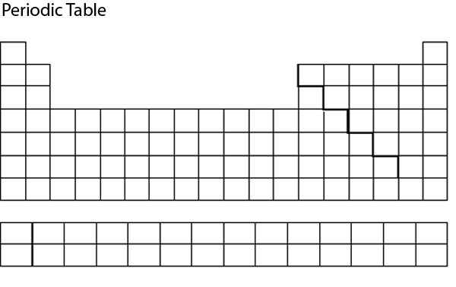
4. Elements on the right side generally form?
NEGATIVE

Except for?
NOBLE GASES
3. Elements on the left side generally form?

POSTIVE
5. Elements in the same family have the same?
ION CHARGE

Except for? TRANSITION METALS

**Patterns occur as a result of regular changes in the STRUCTURE of the atoms of elements.**
- Elements with similar properties line up in columns due to similarities in the arrangement of their electrons.

Valence Electrons Patterns
- The first shell is filled with TWO e⁻ before the second shell is filled.
- The second shell is filled with EIGHT e⁻ before the third is filled, and so on….
- The electrons in the OUTER SHELL have the strongest influence on the properties of an atom.
          - called VALENCE ELECTRONS.

- Most elements in the SAME FAMILY have the SAME NUMBER of VALENCE ELECTRONS, with some exceptions for the transition metals.
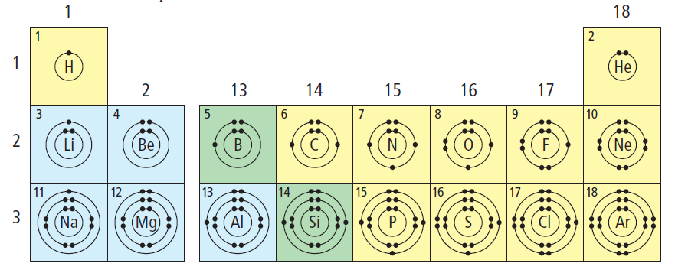

Halogens
7 valence electron
Noble Gas
8 valence electron
Alkaline Earth Metals
2 valence electron
Alkali Metals
1 valence electron

Why are Noble Gases considered unreactive?
STABLE, FULL VALENCE SHELL

- Elements in the SAME PERIOD have valence electrons in the SAME SHELL.
  - Ex. Carbon and oxygen are both in period 2, so they both have valence electrons in the SECOND shell.
- The PERIOD NUMBER indicates the NUMBER OF SHELLS that have electrons.
  - Ex. Elements in period 2 have TWO electron shells.

