2.3 The Periodic Table and Atomic Theory
(Refer to pp. 64 – 71 of BC Science 9) Name:
Date:
Block:
ReVIEW: How Atoms Become Ions
        - Atoms try to get to the level of stability of noble gases by _____________ or ___________________ electrons.
- Atoms of metals lose e⁻ to form ____________ ions.
- Atoms of non-metals gain e⁻ to form _________ ions.
- Ion charge shown on the symbol by a superscript number followed by a ____ or ____ sign.
          - Equal to the ________ of charges of its protons and electrons.

BOHR MODEL DIAGRAMS
- a diagram that shows how many ________________ are in each region (aka ________________ __________) surrounding the nucleus.
- Each shell can only hold a __________ ____________ of electrons.
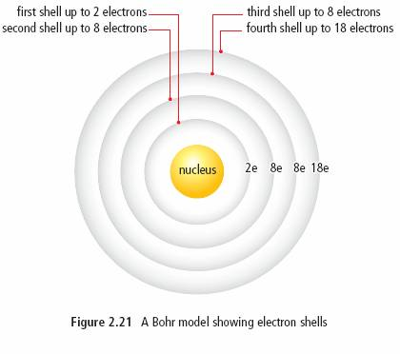
Shell # | # of electrons
1st Shell | 2
2nd Shell | 8
3rd Shell | 8
4th Shell | 18

Three ways that the Bohr model for a potassium atom can be drawn:

Bohr model diagrams usually include:
- The element ___________________.
- The number of _______________ in the nucleus.
- The number of _______________ in the nucleus.
- The number of _______________ and where they are located (on which ____________ they are located) around the nucleus.
YOUR TURN!
Draw the following Bohr Model Diagrams
Sodium | Fluorine

PATTERNS IN THE PERIODIC TABLE
- Atomic numbers increase by _____.
- Atomic ______ tends to increase along with the atomic number, with some __________________.
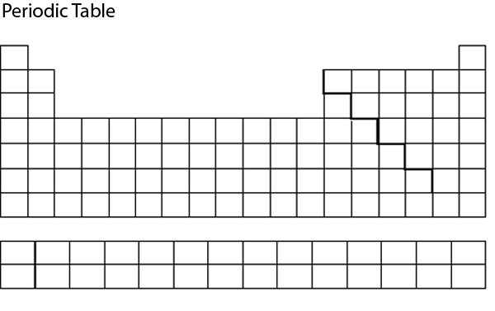
4. Elements on the right side generally form?

Except for?
3. Elements on the left side generally form?
5. Elements in the same family have the same?

Except for?

**Patterns occur as a result of regular changes in the ____________ of the atoms of elements.**
- Elements with similar properties line up in columns due to similarities in the arrangement of their electrons.

Valence Electrons Patterns
- The first shell is filled with ___ e⁻ before the second shell is filled.
- The second shell is filled with ___ e⁻ before the third is filled, and so on….
- The electrons in the ___________ _________ have the strongest influence on the properties of an atom.
          - called ________________ ________________.

- Most elements in the _________ ___________ have the ________ _____________ of ____________ __________________, with some exceptions for the transition metals.
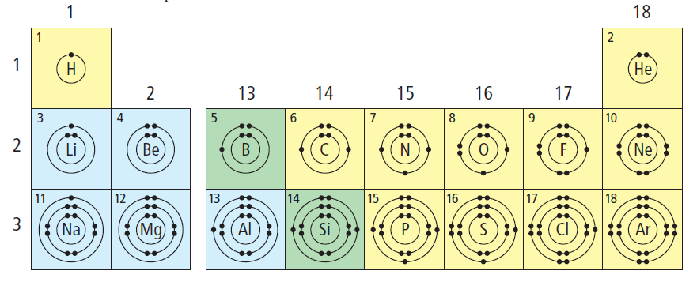

Halogens
7 valence electron
Noble Gas
8 valence electron
Alkaline Earth Metals
2 valence electron
Alkali Metals
1 valence electron

Why are Noble Gases considered unreactive?

- Elements in the __________ ______________ have valence electrons in the ___________ ________.
  - Ex. Carbon and oxygen are both in period 2, so they both have valence electrons in the _____ shell.
- The _______________ _______________ indicates the ___________ ____ _________ that have electrons.
  - Ex. Elements in period 2 have ____ electron shells.

