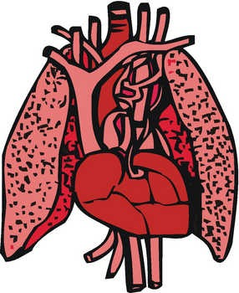**2.3 THE CIRCULATORY AND RESPIRATORY Systems**

**(PART 2) Name:**

**Date:**

**Block:**

**(Refer to pp. 90 – 95 of BC Science 8)**

**The Respiratory System**



* **respiratory system**: the body system that supplies blood with _____________ and removes ___________ ____________ from the blood.



* The two **__________** are important organs in this system
  + - They bring in oxygen for _____________ _________________



* + - They ______________ carbon dioxide.



* __________________ is the process that brings oxygen into your nose or mouth.
* When you inhale, air is filtered by tiny hairs called **__________**.



* + - Cilia and mucus _______ dirt and other particles.
    - The particles are either pushed back out the _____________ or flushed down into the _________________ system.



* Air passes through your **_________** (voice box) and continues down your **__________** towards your lungs.



* 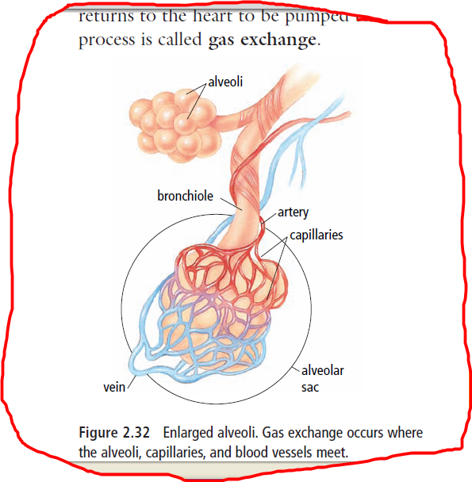At the base of the trachea are two tubes called **________________**.



* Bronchi branch into smaller air tubes called **_____________________**.



* Finally, the air reaches tiny, thin-walled sacs called **_____________**.



**Gas Exchange in the Alveoli**



* 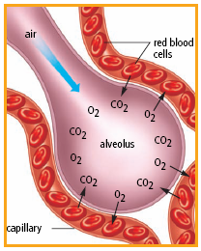 There are millions of alveoli at the ends of the bronchioles, and this is where **______ _______________** takes place.



* + - Oxygen and carbon dioxide move back and forth between the __________ and the surrounding _________ ____Capillaries __________.



**Smoking**



* Smoking may cause both _______________ disease and ____________ disease.



* Respiratory diseases could include _______________ and ________ ____________.



* + Emphysema causes the alveoli walls to lose their _______________. This may make breathing very difficult.



* Smoking also destroys the _________ ____________ in your respiratory system.

**SUMMARY:**