Chapter 2  2.1 | WHMIS  P. 94-109 BC Science Connections
Vocabulary & Concepts
toxic |  | corrosive | oxidizing | WHMIS

What is WHMIS?

WHMIS stands for ____________________________________________________________________________

WHMIS includes safety guidelines on how to be safe in a laboratory, and symbols to describe chemicals.

Things to be aware of before entering a laboratory |  | How you should be dressed while doing a lab
How you should act in a lab |  | How you should work with open flames
How you should work with chemicals |  | How you should clean up spills
What you should do if you break glassware |  | What will happen if you act irresponsibly

Symbol | Symbol Name | What does it mean?
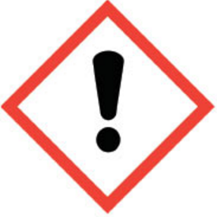
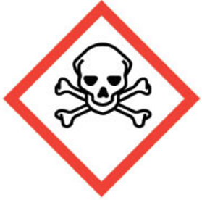
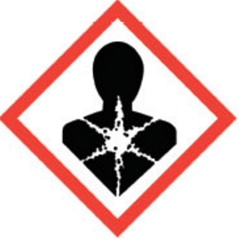
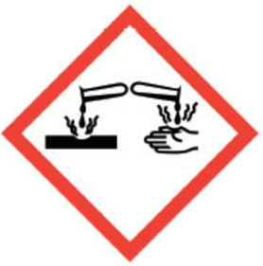
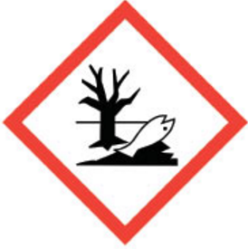
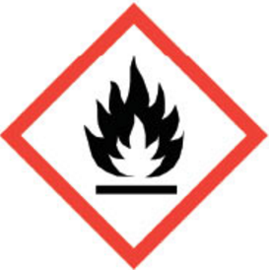
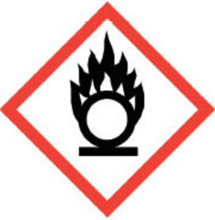
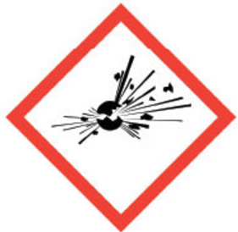
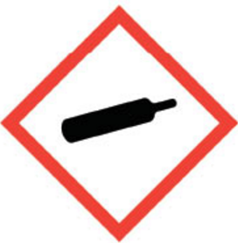
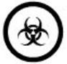

Tear this page out of your notes

Cut the following WHMIS symbol names and explanations out to match to the symbols on the previous page. Ask your teacher to check your work before you glue them down!
Environment | This substance might cause you some health effects, or damage the ozone layer.
Corrosion | These gases are kept under high pressure. Avoid bumping into these, otherwise they may explode.
Flame | This substance might explode or is so reactive that it might explode. Keep this material away from other chemicals.
Exclamation mark | This substance might cause you serious health issues. Do not inhale/ingest these materials.
Gas cylinder | This substance easily oxidizes, which means it releases oxygen. Keep this substance away from flames because oxygen make fires more violent.
Health hazard | This substance will harm the aquatic environment. Do not pour it down the sink!
Biohazardous infectious materials | This substance is flammable, or can easily catch on fire. Avoid putting this substance near a heat source.
Exploding bomb | This substance can burn your skin and eat through metal. Avoid touching these substances unless you are wearing gloves.
Skull and crossbones | This substance contains organisms or toxins that cause disease in people and animals. Wear gloves when handling these and do not inhale them!
Flame over circle | This substance can cause death. It is harmful even in small amounts, and even if you are exposed to it for a short amount of time. Do not ingest!

Chapter 2  2.2 | Classification of Matter  P. 110-131 BC Science Connections
Vocabulary & Concepts
matter |  | pure | mixture | compound
element |  | suspension | mechanical mixture | solution
physical property |  | chemical property | physical change | chemical change

What are “stuffs” and “things” and “substances”?

Anything that has ________________ and ___________________ is referred to as matter. Basically, anything that has a ______________ and _____________________________ is considered matter.

There are many types of matter – carbon dioxide, water, silver, milk – so scientists have created a classification system to make sense of it all.

Describing Matter Using Physical Properties

A physical property is something you can observe without changing the matter you are observing into something else.

Melting Point and Boiling Point |  | Conductivity
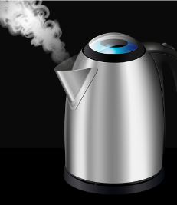 |  | 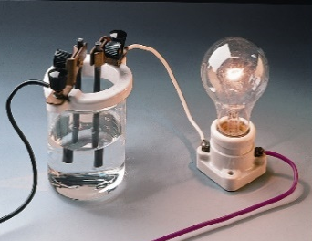
Solubility |  | Hardness
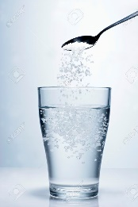 |  | 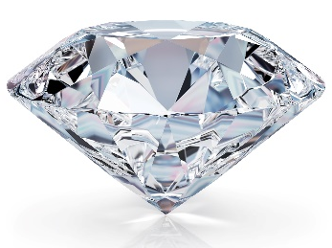
Lustre |  | Viscosity
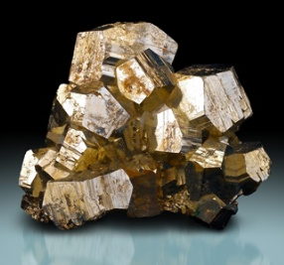 |  | 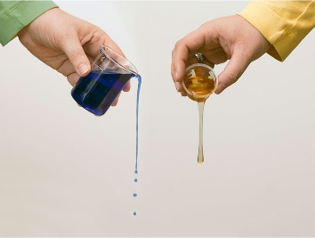
Malleability |  | Ductility
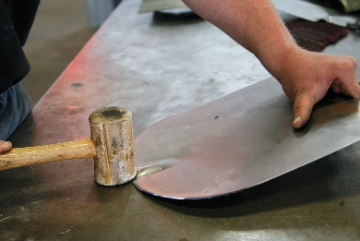
Density |  | Other Physical Properties

Describing Matter Using Chemical Properties

A chemical property is something you can observe only when the matter is changing into something else.

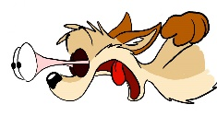
Demo Time! Watch the demonstration by your teacher and record some observations below. Write down the substances your teacher is using and how they react with other substances. Listen carefully so you don’t miss out!

Inert |  | Reacts with acid
Combustible or flammable |  | Reacts with oxygen

Physical Changes
The composition of the substance remains the same. Ice, water, and steam are all H₂O.

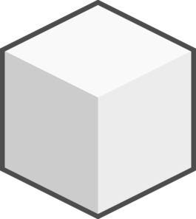
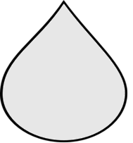

Chemical Changes

The composition of the substance changes, in other words, ________________________________ are formed. __________________________________ will be observed!
Brainstorm

How can you tell if a change is a chemical change?

Chapter 2  2.3 | Kinetic Molecular Theory  P. 132-151 BC Science Connections
Vocabulary & Concepts
State/phase |  | kinetic molecular theory | compressible | thermal expansion | theory

The States of Matter

 | Solid | Liquid | Gas
What it looks like | 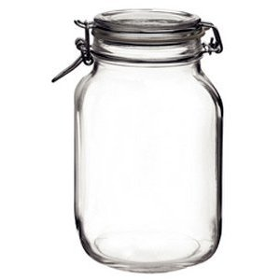
What particles are doing
Energy of the particles
Can it be compressed?
Volume of the material
Examples

The Kinetic Molecular Theory

A theory in everyday speech means a guess. A theory in Science is the opposite! A theory is an explanation of a phenomenon based on MANY experiments and observations. The kinetic molecular theory explains the behavior of matter on the atomic scale. It has four main points:

Critical Thinking

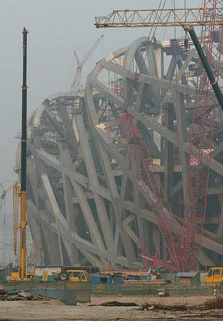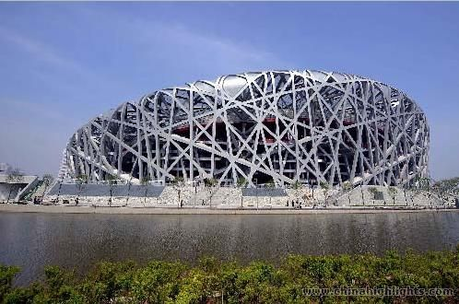

The Bird’s Nest is a stadium built in Beijing for the 2008 Summer Olympics. The structure is made of many interlocking steel beams and took 5 years to build. When the steel beams were placed, workers could not weld them together right away. Instead, they had to wait for a certain time of day to do the welding. Why do you suppose that is?

Chapter 2  2.4 | Atomic Theory  P. 152-171 BC Science Connections
Vocabulary & Concepts
atom |  | proton | electron | neutron
quark |  | nucleus | shells | subatomic particle

Atomic Models Through the Ages

The smallest unit of matter is the ________________. It is the smallest particle of an element that retains the properties of that element.

The atom is then made of even smaller particles, called the ________________________________________!

How do we know what the atom is made of and what it looks like? Read P. 154-160 in BC Science Connections to complete the table below.

Scientist | The Model  Draw the model and label it. | The Experiment  Describe what lead to the model. | Major Discoveries and Ideas  What did this scientist discover about the atom?
Democritus  Proposed model 460 BC |  | - no experiment  - just thought about it  - used reason and logic | - matter is made of small particles in empty space  - Particles are solid, can’t be destroyed, invisible  - different types of particles have different shapes and sizes  - characteristics of the particles determine the properties of matter
John Dalton  Proposed model 1800 | 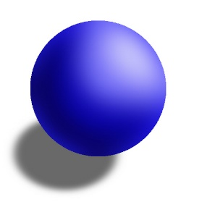  solid sphere
J.J. Thomson

Proposed model 1897

Scientist | The Model  Draw the model and label it. | The Experiment  Describe what lead to the model. | Major Discoveries and Ideas  What did this scientist discover about the atom?
Ernest Rutherford

Proposed model 1911
Niels Bohr

Proposed model 1912

The Bohr Model

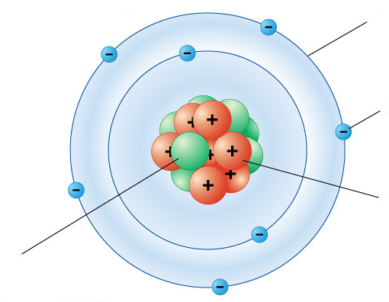

SUMMARY
 | Protons | Neutrons | Electrons
What is its symbol?
What is its charge?
Where is it in the atom?
Does it determine what element the atom is?
Is it made of even smaller particles?

