****Name: Date:



**Chemistry: Pure Substances & Atomic Theory**

**Text pages**: *pgs 23 to 33 (Sections 1.2 and 1.3)*

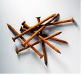**Purpose:** To understand the two main categories of pure substances as well as learn the atomic theory.

* **chemical change:** ______________________________________________________

_____________________________________________________________________

* chemical bonds are formed and broken.

Ex. “Dancing Raisins”

The reaction is: CH3COOH(aq) + NaHCO3(aq) → NaCH3COO(aq) + H2O(l) + CO2(g)

What chemical compounds are the reactants?

What chemical compounds are being produced during this reaction?

* pure substance: ______________________________________________

___________________________________________________________

* 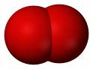There are 2 kinds of pure substances:

1. element: _____________________________________

________________________________________________

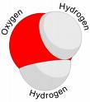Ex. oxygen

1. compound: _____________________________________

_________________________________________________________

Ex. water

* atom: _______________________________________________________________

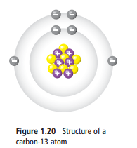 _______________________________________________________________

* subatomic particles: ____________________________________________________ _____________________________________________________________________
  + there are ____ kinds:
  1. __________________
  2. __________________
  3. __________________

|  |  |  |  |  |
| --- | --- | --- | --- | --- |
| Name | Symbol | Relative Mass | Electric Charge | Location in the Atom |
|  |  |  |  |  |
|  |  |  |  |  |
|  |  |  |  |  |

Read the information covered on page 32-33 about the subatomic particles. Make notes on mass, electric charge, the nucleus and electrons that you have not covered above.

|  |  |
| --- | --- |
| Mass | Electric Charge |
| The Nucleus | Electrons |