****Name: Date:



**Chemistry: Pure Substances & Atomic Theory**

**Text pages**: *pgs 23 to 33 (Sections 1.2 and 1.3)*

**Purpose:** To understand the two main categories of pure substances as well as learn the atomic theory.

* **chemical change:** a change in matter when substances combine to form new substances
* chemical bonds are formed and broken.

Ex. “Dancing Raisins”

The reaction is: CH3COOH(aq) + NaHCO3(aq) → NaCH3COO(aq) + H2O(l) + CO2(g)

What chemical compounds are the reactants?

Acetic acid (AKA vinegar) and sodium bicarbonate (AKA baking soda)

What chemical compounds are being produced during this reaction?

Sodium acetate, water and carbon dioxide

* pure substance: A substance that is made up of only one kind of matter (particle)
* 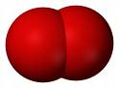There are 2 kinds of pure substances:

1. element: cannot be broken down or separated into simpler substances

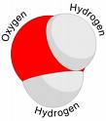Ex. oxygen

1. compound: composed of at least two elements combined in a specific way

Ex. water

* 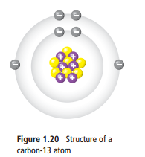atom: the smallest particle of an element that retains the properties of

the element.

* subatomic particles: smaller particles that make up an atom
  + there are 3 kinds:
  1. Protons
  2. Neutrons
  3. Electrons

|  |  |  |  |  |
| --- | --- | --- | --- | --- |
| Name | Symbol | Relative Mass | Electric Charge | Location in the Atom |
| Proton | P | 1836 | + | Nucleus |
| Neutron | N | 1837 | 0 | Nucleus |
| Electron | E | 1 | - | Surrounding the nucleus |

Read the information covered on page 32-33 about the subatomic particles. Make notes on mass, electric charge, the nucleus and electrons that you have not covered above.

|  |  |
| --- | --- |
| Mass   * Protons and neutrons have a mass about 1800 times greater than the electron | Electric Charge   * Protons and electrons are attracted to another * All atoms have equal number of protons and neutrons: charges add up to 0, making an atom neutral |
| The Nucleus   * Always has a positive charge * Tiny region in centre of atom * Hydrogen only atom that does not have any neutrons | Electrons   * Electrons occupy most of space of an atom (99.9%) * Each electron occupies one whole energy level at a time |