Lesson One: Space Travel
Name: KEY
Part A: BBC documentary Space Travel – Ideas for future travel https://www.youtube.com/watch?v=AtlPX54eizc
What are the PROS and CONS for Space Travel? (*Watch 0-20min. then 26min – 30min*)
PROS | CONS
- Witness the ‘comos’ in-person  - ‘Visual’ of the earth  - An experience of a lifetime | - COST  - Space is like a ‘shooting’ gallery (TIME – 5 min)  - Radiation (protected by magnetic field and ozone layer) (TIME – 6 min)  - Sun spots (TIME – 8 min)  - Galactic Cosmic Rays (particles travelling at speed of light *if outside space shuttle*  - Loss of gravity (sense of direction, muscle atrophy, digestion) (TIME – 10 min)  - Immune system (not as effective, bacteria 50 times faster) (TIME – 13 min)  - Temperature swings (facing sun, not facing – 1000)  - Machinery risk (rapid decompression, isolation)  Repairs (tools onboard and human ingenuity) (TIME – 15 min)

- List new space initiatives / ideas that are discussed during the movie. How would these help space travel?
Space Elevator – replace conventional rocket launch, would reduce cost by 1000
(TIME – 3 min)
- Where can we travel to, realistically, within our solar system? Why? How long would it take to travel to Jupiter? Saturn?
  - Only the planets due the lengthy travel (we need to be ‘alive’ when we arrive)
  - 5 yrs, 10 yrs
  - (TIME – 20min)
- What are some of the challenges travelling to Mars?
  - Earth aligns with Mars every 2 years (104 days there, 6 mths home)
  - If the Earth was not aligned – it would take approx. 20 mth return home.
  - (TIME – 22 min)
- What ideas could help humans make space travel more attainable? Any technologies?
  - TIME – 26 min
  - Travelling faster
    - Solar Sails
    - Hydrogen Fusion reaction
    - Anti-matter – conversion of anti-matter to energy! (cost very high)

Part B: How much $$ would you give to Space Exploration? Travel? New Technologies?
Annually, the Canadian government collects tax dollars (i.e. income tax and sales tax), money they can spend at their digression. In 2014, the government spent $276.8 billion. Keep in the mind, this represents roughly 15% of the economy’s 1.9 trillion dollar economy. The government then has to decide which sectors to spend the tax-payers money. Bottom line, how much did the governments spend on Space Exploration and Technology in 2014?
If you were in charge of the government for 2016, how would you allocate the funds spent by the government?
- Listed below are the categories in which you could spend your money
- Place a percentage beside each category on where you think would best serve our country
SECTOR | PERCENTAGE
Public Safety (i.e. RCMP) | 3
National Defence (i.e. army + navy) | 8
Social Support: (Support to Elderly, Unemployment Insurance, Child Support - $ monthly allocated to families) | 26
Universities and Education | 5
Roads, Bridges, highways, Sewers | 6
Health Canada | 11
Parliamnet | 6
Public Debt | 10
Government Agencies (i.e. Cdn Space Agency, Environment Canada, Transport Canada) | 12

How does Canada compare to other countries?
 | GDP (approx.) | Percentage Spent on Space
USA | 11.8 trillion | 14%
European Union | 11.7 trillion | 3%
Japan | 3.7 trillion | 5%
China | 7.3 trillion | 2%
Russia | 1.4 trillion | 6%
India | 3.3 trillion | 3%
Canada | 1.9 trillion | 0.1%

PART C: The benefit of Space Exploration - Spinoff Technologies
Watch…’We Stopped Dreaming…’ (https://www.youtube.com/watch?v=CbIZU8cQWXc)
Without using computers, can you think of any spinoff technologies that would have not existed if NASA had not invented for Space Exploration.
Brainstorm with the person beside you:
1. 20 Everyday Things We Have because of NASA:
http://www.businessinsider.com/everyday-items-developed-by-nasa-2012-8
2. Wikipedia Spin-off Technologies
https://en.wikipedia.org/wiki/NASA_spin-off_technologies

7 Surprising Things that the US government spends more money on than space exploration!
http://www.vox.com/2015/3/24/8279745/space-budget-nasa

* FACT – Due to all of the ‘spinoffs’ that we use from Space Exploration, $8 in goods and services are being used for every $1 spent in Space Exploration! *
Read over this chart (this is testable information)
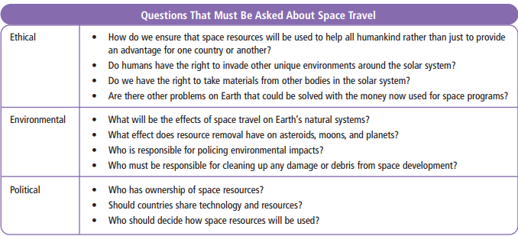

Space Travel to Mars, Documentary with Neil DeGrasse Tyson
https://www.youtube.com/watch?v=218poMeCQ-w

Lesson Two: Space Technologies
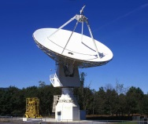
*You may get this information from the video or Chapter 12.3 in the BC Science Textbook*
Why is there a need for space-based observation technology?
- Learn, discover, create new spinoffs, prevent disasters
Briefly describe the following 3 most successful advanced technologies:
Satellites: electronic devices that orbit round the sun and send info back to earth
Rovers: robotic devices that move round the surface of a planet, moon
Probes: space vehicles, sent to other planets, travel long distances, collect data

(Watch the Video - A rover used to explore asteroids) http://www.nasa.gov/directorates/spacetech/home/index.html
What is the force that pushes a rocket to move? Why are space shuttles better than rockets?
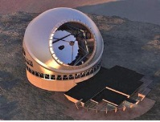
- A upward force, enough force that propels out of our atmosphere
- burns fuel
What is the main reason why countries are working together on space exploration?
- Cost, man-power

What’s Next (pg 445)?
How will a ‘space Sled be useful?’
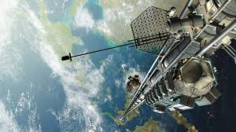
- NASA will use magnets to propel a spacecraft along a rail at 600km/hr, goal is to aid in the air craft to get out of the atmosphere

What is a ‘space elevator’? How does it work? How much would one trip cost?
(Watch the video: The Space Elevator https://www.youtube.com/watch?v=pnwZmWoymeI )
- Uses an elevator to transport people and supplies to Earth’s orbit
- A long cable is attached to the earth that would propel a platform upward towards space using laser beams.
- The cable would be 36000km long, costing $22000 / kg to transport materials and a 5 hr ride

Check out this website!
https://www.nasa.gov/content/nasas-journey-to-mars

SSSSS
