Comparison Diagram of human lifetime and star lifetime http://goo.gl/9Gd122
Stars and humans share similar phases in their lives. Fill in this diagram to compare them.
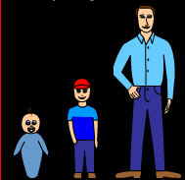

Different Phases of a Star
- Watch the following video about a star’s life cycle. http://goo.gl/LUs83t
- Class Demonstration: Star Model
Different Phases of Stars (Dependent on Solar Masses)
Mass of Star (Solar Masses) | Balloon represent-ing this star | The star’s phases as it progresses through its life cycle (up to 5 stages) | Age of star before it dies (millions of years)
0.4
1
10
25
Results & Conclusion
- Create a flow chart for the different phases a star can go through in the space below. Be sure to incorporate the different sized stars and the resulting life phases.

- What was your favorite star? Why?

- Explain in a short paragraph what you learned from this activity.

