Name:____________________
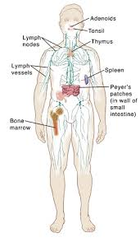
1.5 – The Immune System
(Refer to pages 48 – 50)

** Complete Activity 1-D (pages 56 – 59)
Explain how this activity demonstrates how an infection disease is transmitted

- Immune system = the system that defends the body against _________________ and
_____________________ substances such as bacteria, viruses and cancer cells.
- contains several lines of defence that help protect us from _________________ (microorganism that can cause disease)

The first line of defence is the ____________ and ___________________________________.
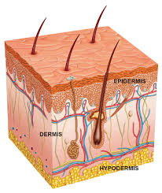
The skin is a _______________________ to keep pathogens from entering your body
        - Your skin also produces ___________ and _________________ that can kill some pathogens on the surface of your skin
In your respiratory system __________ and ____________________ structures in your nose and throat trap pathogens and move them back out of your body.
        - ____________ and ________________ are the results of this
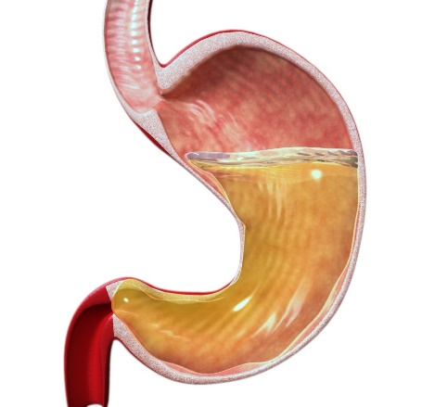
In your stomach you have _______________ which kills many types of
Pathogens
  - ___________ in the digestive system traps pathogens, and _______________ removes them from your body
How might our immune system be different without this first line of defence?

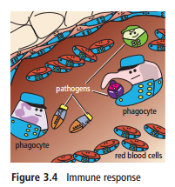

If a pathogen makes it past the first line of defence your body will attack and destroy the invader.
The second line of defence in the immune system is ______________
  - White blood cells can __________ and _________ invading pathogens. They can also release ________________ to make it easier for other white blood cells to attach pathogens.

Inflammation = causes the affected area to become red and swollen
  - This is your body’s natural response to an ____________ or _________________
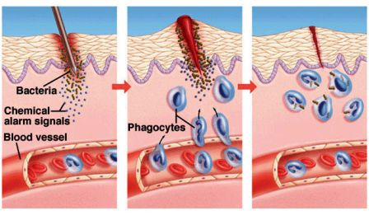
  - __________________ move to the area, killing pathogens and keeping infection from __________________

The third line of defence uses _______________ white blood cells
  - In future, if the same pathogen enters the body, these ________________________ can respond quickly so that you do not become sick
Why does inflammation occur after an injury or infection? How does this help your immune system fight disease?

1.5 (continued) - Outbreaks of disease can have an impact on populations

Quick Thinking: What major disease outbreaks can you think of and how did they affect the world?

Epidemic | Outbreak | Pandemic

Epidemics and Pandemics can have both ___________ and __________ impacts on human populations

Classify each of these cases as a social impact, an economic impact, or both.
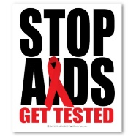  HIV has killed more than 25 million people since it was first identified in 1984. In just the first two decades of the 21st century, more than 1 million people have died due to diseases such as SARS, H1N1, measles, and typhoid.  Social, economic, or both? Why? | Some livestock animals can pass on diseases to people. In 2015, an outbreak of bird flu forced poultry producers to kill 50 million chickens and turkeys. The price of eggs increased, and farmers lost millions of dollars.  Social, economic, or both? Why?
Sick days take their toll. Flu alone results in losses of half a billion dollars each year to the Canadian  economy.  Social, economic, or both? Why? | Taking extra precautions, as well as concerns about fear and panic, can lead governments to restrict travel as well as the importation of foods.  Social, economic, or both? Why?

Throughout history deadly diseases have struck human populations. Over time some of these populations have developed and ________________ to these diseases.

Immunity = the ability of an organism to resist a particular infection or toxin by the action of specific antibodies or _______________________________.
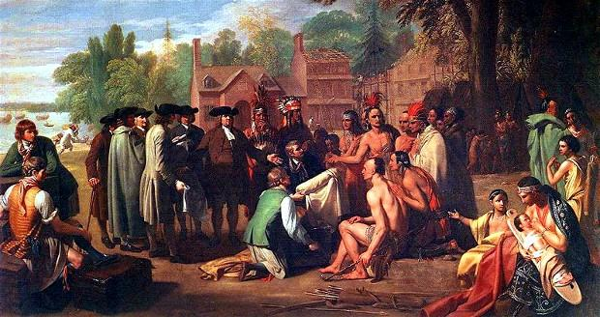
Smallpox
Europeans had built up an immunity to smallpox after hundreds of years of exposure to the disease. When Europeans first visited North and South America they brought the disease, along with measles, with them. The First Nations had never been in contact with the disease before which resulted in larger numbers dying

Some populations have a ________________ to a disease. These populations have immune to a disease without _______________________________________ by the disease
These small populations with natural immunity help scientists learn more about:

How does a population develop an immunity to a disease? How is this different than a natural immunity to a certain disease?

