Chapter 1  1.5 | The Immune System  P. 54-63 & P. 100-119 BC Science 8, P. 48-63 BC Connections
Vocabulary & Concepts
body system |  | immune system | lines of defense | inflammation
antigen |  | white blood cell | outbreak | epidemic
pandemic

The Body Systems

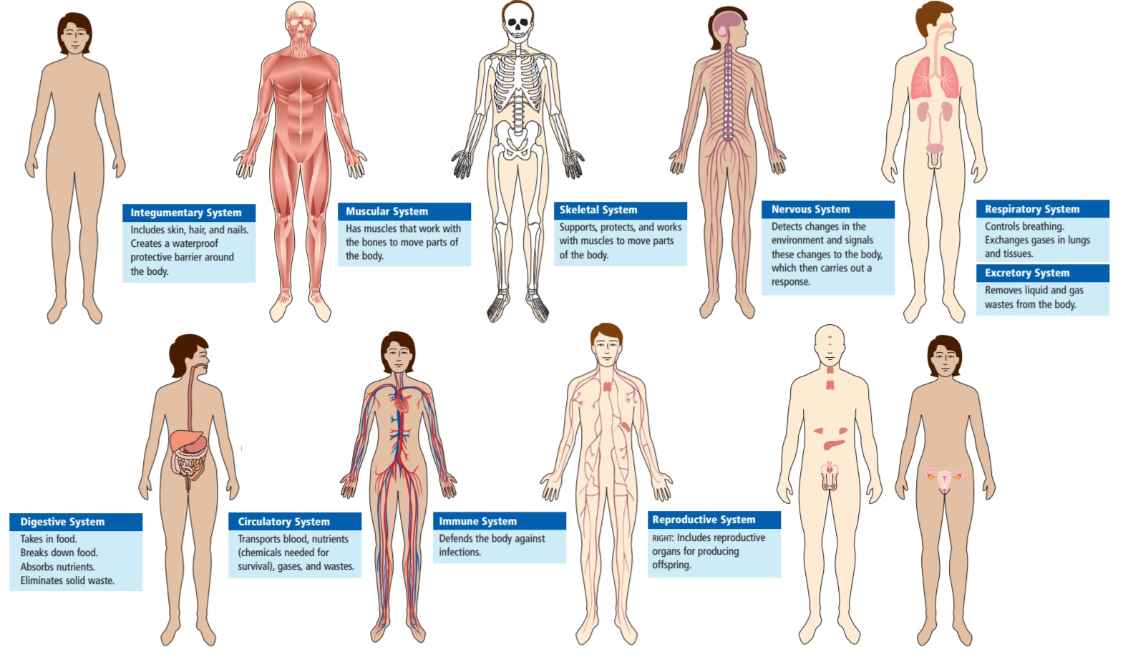
The Immune System

Brainstorm: What do you already know about the immune system? What organs or body parts are involved in the immune system?

The immune system defends the body against infection and disease causing substances such as bacteria, viruses and cancer cells. It contains several lines of defense that help protect us against these _______________________.
The 1st line of defense
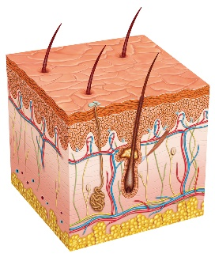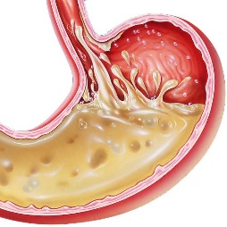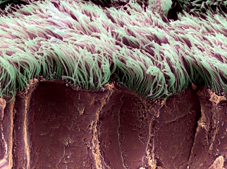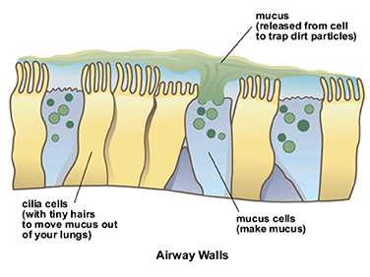

The first line of defense includes
- ______________________________________
- _____________ and ____________________________ that kill pathogens on the skin’s surface
- ____________________________ in the respiratory system to trap and sweep pathogens away
- ___________________ and ___________________ to trap pathogens
- Strong ______________ in your stomach to kill pathogens

The 2nd line of defense
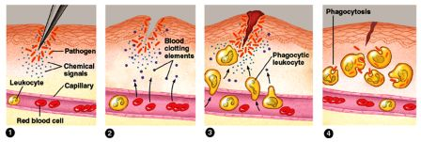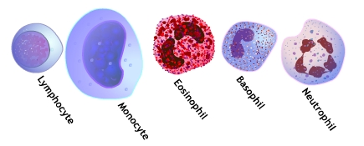

The second line of defense includes
- ___________________________________ which engulf and kill pathogens, release chemicals that aid in this process
- __________________________, the body’s response to injury or infection. The affected area receives ________________________ to allow more white blood cells to arrive. ___________ ____________________________________ for an antibiotic effect.

The 3rd line of defense
The third line of defense includes  - ___________________________________ that remember what a pathogen looks like so that the immune system is ready for future attacks. | 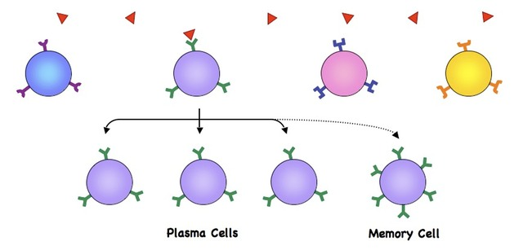

Disease Outbreaks

Brainstorm: What outbreaks can you think of that have happened in history?

Outbreak | Epidemic | Pandemic
A sudden occurrence of a disease in a community where the number of affected individuals is greater than expected.  An example is __________________________ | A disease that spreads to many people rapidly in an area.  An example is  _________________________ | An epidemic that has spread over several countries or continents, or around the world. This is an outbreak on a ________________________.  An example is __________________________

Brainstorm: There is a sudden outbreak of CW virus in West Vancouver. The virus induces severe vomiting and dehydration and has infected 150 individuals over 8 days.

You work for the local health authorities. What steps would you take to insure that the virus doesn’t spread further?

Measures to hinder the spread of the CW virus has failed. You work for Health Canada. What steps would you take to insure that the virus doesn’t spread globally?

Chapter 1  1.6 | Vaccines & Antibiotics  P. 64-79 BC Connections
Vocabulary & Concepts
vaccine |  | immune response | immunity | antibiotic
antibiotic resistance |  | penicillin | superbug | eradicate

Vaccines

Vaccine: ____________________________________________________________________________
____________________________________________________________________________________
- Analogy: We respond to a fake fire in a fire drill by evacuating the building. We are then prepared for a real fire because we have practiced the proper response.
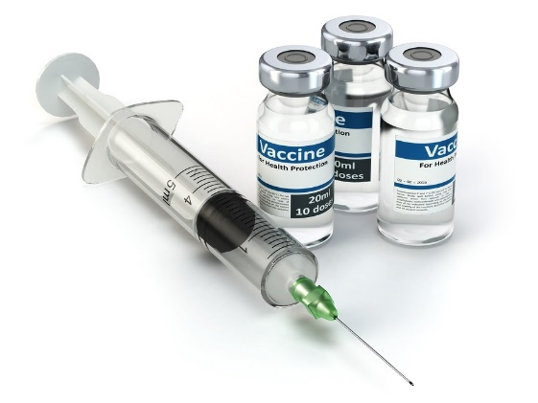
Types of Vaccines
Vaccine Type | How it Works |  | Examples
Live, attenuated vaccine | - you are injected with ______________, but _______________ microbes, that don’t cause disease  - your immune system responds and remembers  - receive lifelong immunity after 1-2 shots |  | Measles  Mumps  Chickenpox  Yellow fever
Inactivated vaccines | - you are injected with ____________ microbes  - your immune system responds somewhat and remembers  - receive immunity ONLY if booster shots are maintained |  | Hepatitis A  Rabies  Whooping cough
Subunit vaccines | - you are injected with ____________________ of microbes  - your immune system responds and remembers  - receive immunity after several doses |  | Hepatitis B  Flu
Toxoid vaccines | - you are injected with _________________________ _____________ from microbes that don’t cause disease  - your immune system responds and remembers  - receive immunity ONLY if booster shots are maintained |  | Diphtheria  Tetanus
Benefits of Vaccines
Individual immunity
Population immunity
Disease eradication
Economic savings

Sometimes people choose not to vaccinate because severe reactions are possible
- high fever
- severe allergic reactions
- brain infection (meningitis)

However, these reactions are very _____________. It is important to remember that the possible side effects for each vaccine is __________________. Over the last decade, it has been scientifically proven countless times that vaccines do NOT cause two side effects that have been popularized on social media: _________________ and ___________________.

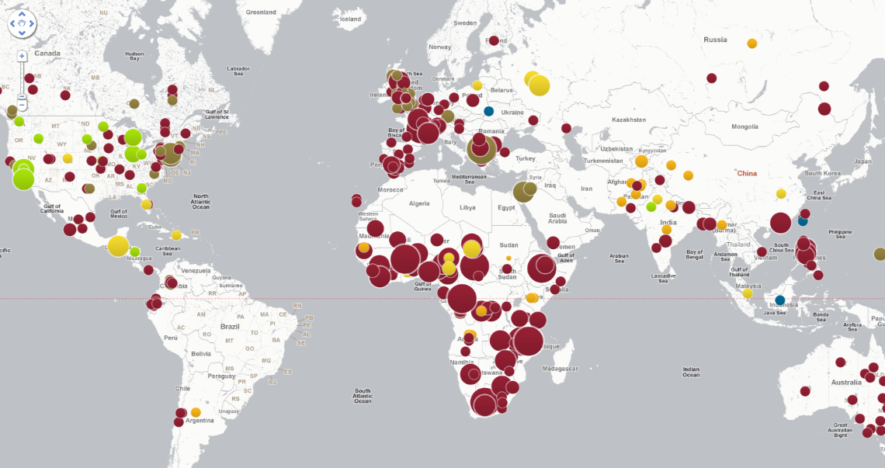
Previously eradicated diseases are now coming back because there has been a decrease in vaccination rates.
Antibiotics

Antibiotic: ___________________________________________________________________________
- ______________________________________________________________________________
- ______________________________________________________________________________
- ______________________________________________________________________________

In your own words: Watch Antibiotic Apocalypse and use the image below to describe what antibiotic resistance is. How does it occur? What is a superbug?

