Chapter 1  1.3 | Types of Cells & Their Parts  P. 24-37
Vocabulary & Concepts
prokaryotic |  | eukaryotic | bacteria | organelle
nucleus |  | cytoplasm | endoplasmic reticulum | ribosome
Golgi bodies |  | vesicles | vacuoles | lysosome
chloroplast |  | cell wall | photosynthesis | cellular respiration

Types of Cells
Cells

Bacteria
Archaea
Plant
Animal
Protists
Fungi
Eukaryotic

These are _______________________________ cells that have many _____________ (internal structures), including a _______________.
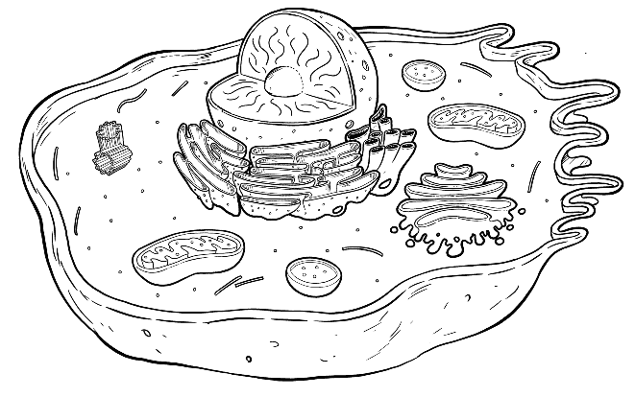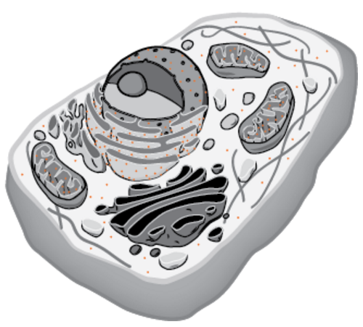

Prokaryotic

These are ________________________ cells that don’t have many ________________ (internal structures). They lack a _____________

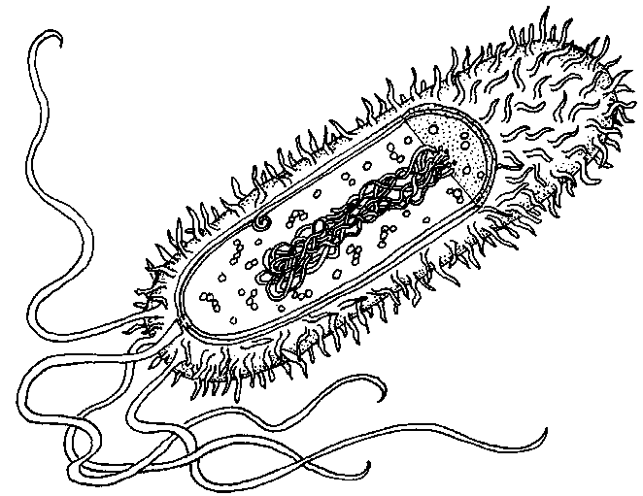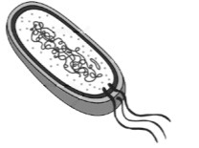

Animal and Plant Cells

Animal | Plant  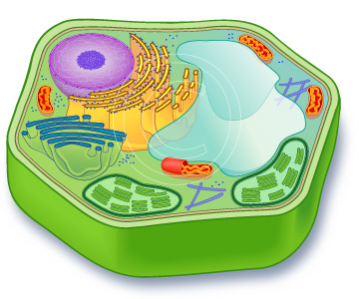

The BIG Summary
Part / Organelle | Function | Animal | Plant  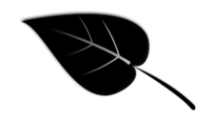
nucleus
endoplasmic reticulum
ribosome
Golgi bodies
vesicle
vacuole
lysosome
mitochondria | Carries out ______________________________________, a chemical reaction that gives the cell energy:
chloroplast | Carries out ________________________________, a chemical reaction that uses _____________ to make sugar.
cytoplasm
cell membrane
cell wall
Chapter 1  1.4 | Micro-organisms  P. 38-45
Vocabulary & Concepts
Micro-organsim |  | microbe | bacteria | pathogen
red tide

What are Micro-organisms?

A micro-organism, or microbe for short, is simply an organism that is really small. Two examples are _________________ and ____________________________

Microbes are our friends!
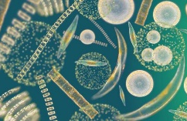
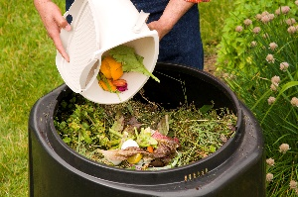
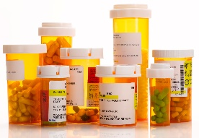
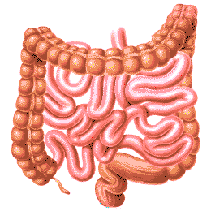

Microbes are not our friends
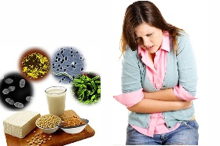
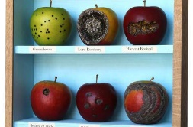
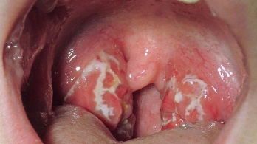 | ______________________ are microbes that are harmful to people. Streptococcus bacteria is an example. It causes strep throat. Other examples include __________________, ________________, ___________________.
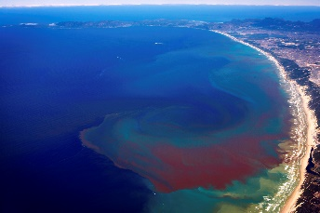 | When phytoplankton in the ocean grow out of control, it causes ____________________________. The phytoplankton produce _________________ (harmful chemicals) that end up in shellfish. Eating the shellfish during this time will result in serious _______________________________.

