Venn Diagram Comparing Animal and Plant Cells Name:
Block:
*Use the animations provided on my website (www.msramsden.weebly.com) to help you complete the venn diagram
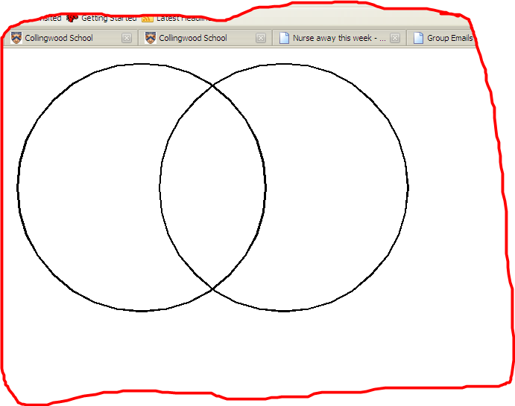
Animal Cells Both Plant Cells

Venn Diagram Comparing Prokaryotic and Eukaryotic Cells
**Use the picture found on my website and your notes to help you complete the venn diagram
Prokaryotic Cells Both Eukaryotic Cells

