Chapter 1  1.1 | Observing Living Things  P. 11-21 BC Science 8
Vocabulary & Concepts
unicellular |  | multicellular | compound microscope | magnification power
resolving power

Examining Very Small Living Things

Brainstorm: Why are we interested in seeing very small things? What do we need to see very small things?

The _microscope_ is used by scientists to observe small unicellular and multicellular things.
- There are many different types:
  - Magnifying glass
  - Compound light microscope
  - Transmission electron microscope (TEM)
  - Scanning electron microscope (SEM)
- Early microscopes were built in the late 1600s and early 1700s
- _Anton van Leeuwenhoek_ was one of the first people to build a microscope
  - Could magnify up to _250X_ and used it to observe microscopic living things

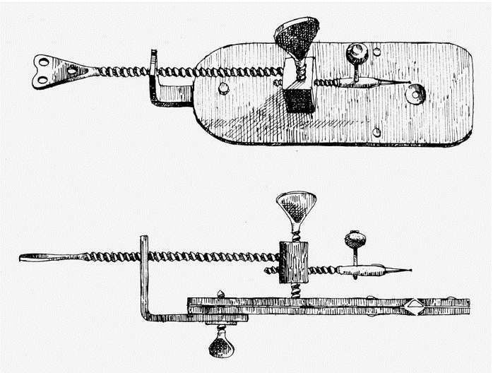

The Modern Compound Light Microscope

Resolving nosepiece

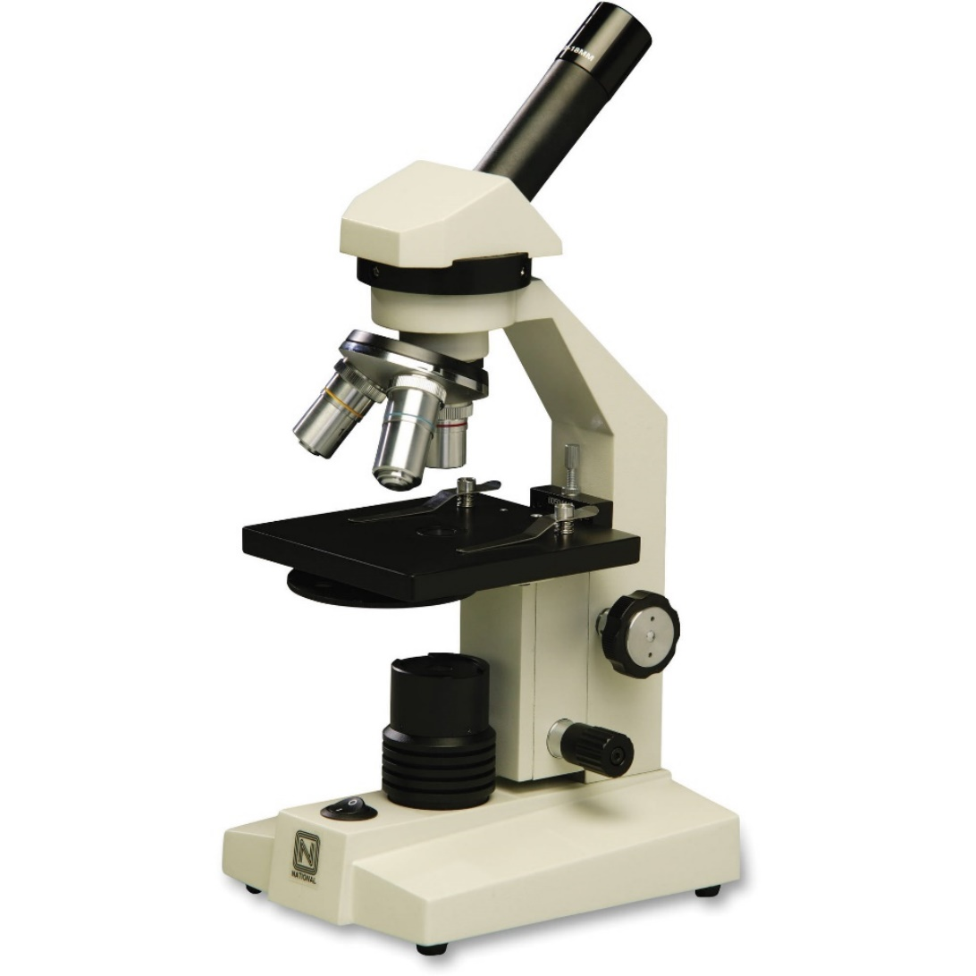
Objective lenses
Stage
Light source
base
Fine focus knob
Coarse focus knob
arm
eyepiece

How the Compound Microscope Works
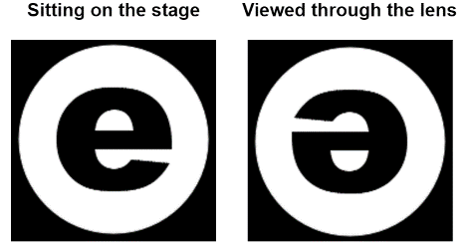
The compound light microscope has 3 sets of lenses that magnify an image. The image you observe is magnified, inverted and reversed

Each objective lens has a different magnification power: _the number of times larger an image appears under a particular lens

Total magnification power = low power objective lens x eyepiece lens

Power | Objective Lens Magnification | Eyepiece Lens Magnification | Total Magnification Power
Low | 4 | 10 | 40
Medium | 10 | 10 | 100
High | 40 | 10 | 400

Most people can see only dots separated by 0.1 mm or more in the diagram below. This means that most people can see the individual dots in diagrams A, B and C, but do not have the resolving power to see the dots in diagram D.
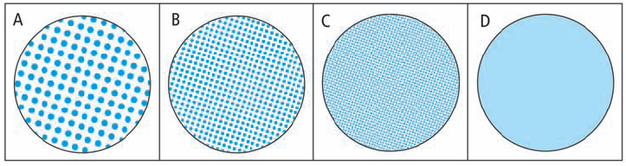

Resolving power: _the ability to distinguish between two dots or objects that are very close together_
- The microscope extends human vision by enabling us to view objects that are smaller and closer together.
- The compound light microscope has a resolving power of 0.2 microns (μm) A micron or micrometre is a millionth 10⁻⁶ of a metre.

