Chapter 1  1.1 | Observing Living Things  P. 11-21 BC Science 8
Vocabulary & Concepts
unicellular |  | multicellular | compound microscope | magnification power
resolving power

Examining Very Small Living Things

Brainstorm: Why are we interested in seeing very small things? What do we need to see very small things?

The ___________________ is used by scientists to observe small unicellular and multicellular things.
- There are many different types:
  - Magnifying glass
  - Compound light microscope
  - Transmission electron microscope (TEM)
  - Scanning electron microscope (SEM)
- Early microscopes were built in the late 1600s and early 1700s
- ______________________________________________ was one of the first people to build a microscope
  - Could magnify up to ___________ and used it to observe microscopic living things

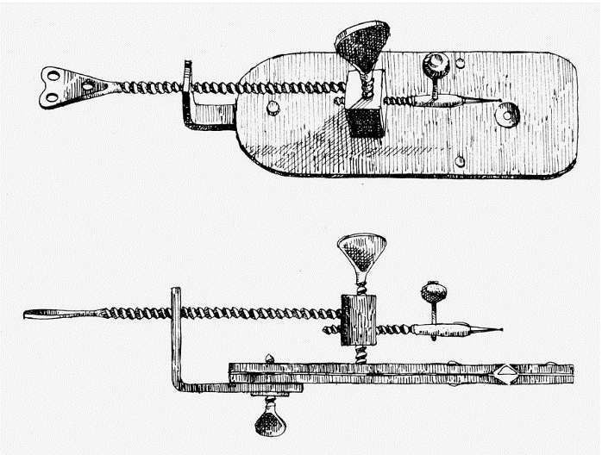
The Modern Compound Light Microscope

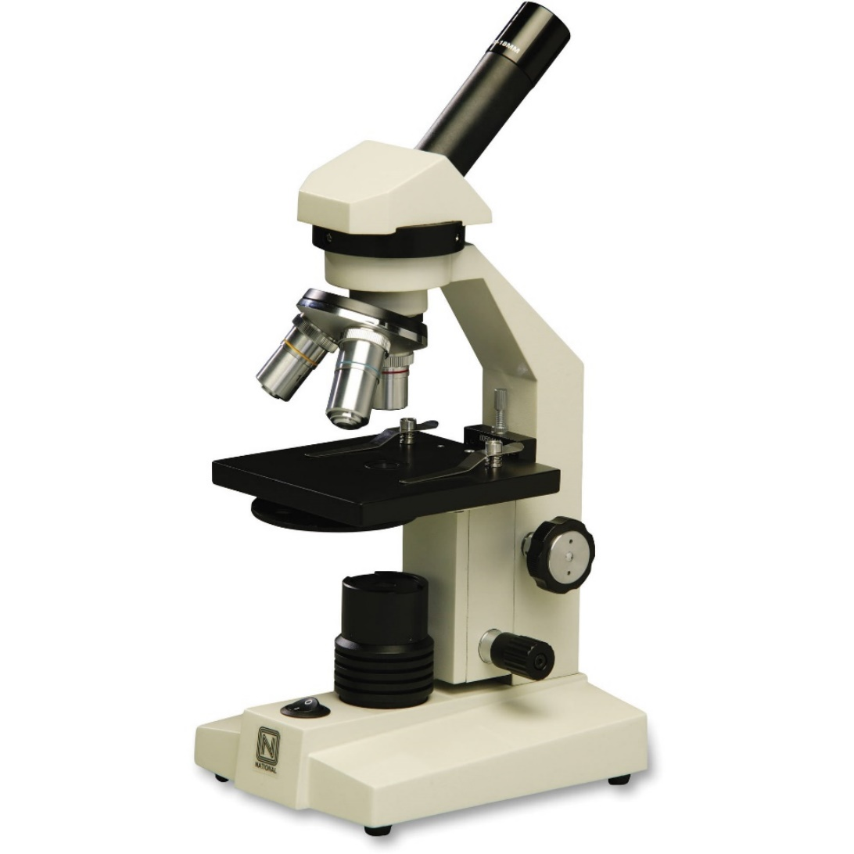

How the Compound Microscope Works
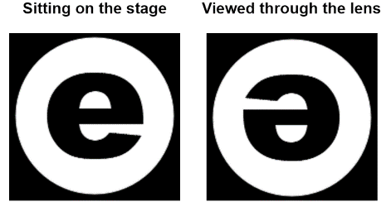
The compound light microscope has _________ sets of lenses that magnify an image. The image you observe is ________________, __________________, and _________________________.

Each objective lens has a different magnification power: ____________________________________________________________________________________

Total magnification power =

Power | Objective Lens Magnification | Eyepiece Lens Magnification | Total Magnification Power
Low
Medium
High

Most people can see only dots separated by 0.1 mm or more in the diagram below. This means that most people can see the individual dots in diagrams A, B and C, but do not have the resolving power to see the dots in diagram D.
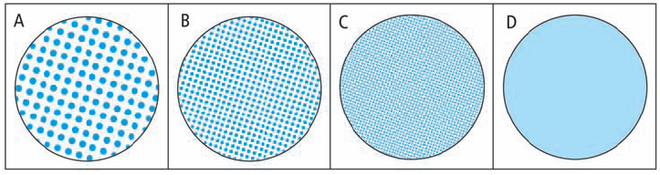

Resolving power: _____________________________________________________________________
- The microscope extends human vision by enabling us to view objects that are ________________ and ______________ together.
- The compound light microscope has a resolving power of ______________________________. A micron or micrometre is _________________.

