Chapter 1  1.1-1.2 | Characteristics of Life  P. 6-19
Vocabulary & Concepts
unicellular |  | multicellular | bacteria | virus
Cell Theory

What makes something alive?

Brainstorm: What do all living things have in common? What characteristics do all living things have in common? What do all living things do?

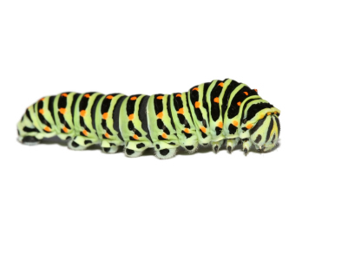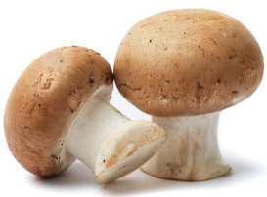
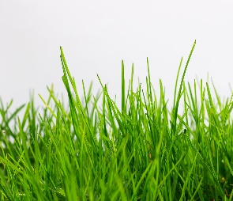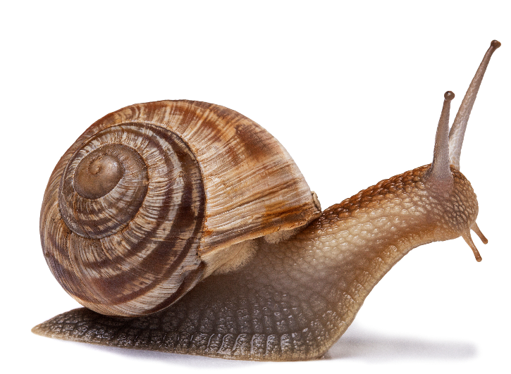
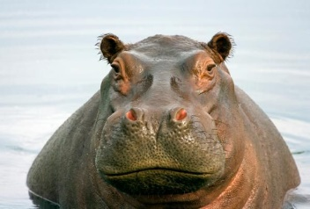

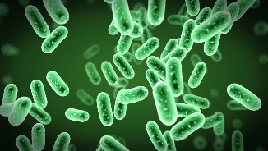

Consider This: With a partner, read the following about a bacteria and virus, then decide whether they are alive or not.

Streptococcus Bacteria  The streptococcus bacteria is a single spherical cell, but can grow into long chains, like a microscopic pearl necklace. To grow, the bacteria splits itself in half and becomes two! If it ever finds itself in your throat, you develop strep throat. There, it absorbs nutrients through its thin cell membrane and releases wastes.  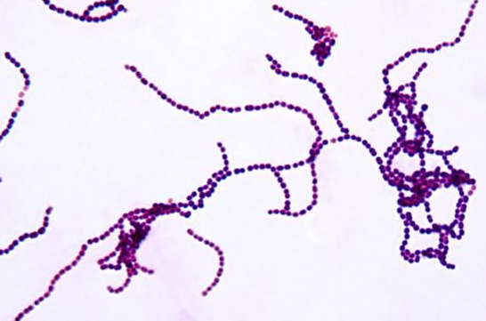  Is streptococcus alive? Why or why not? | Human Immunodeficiency Virus (HIV)  The HIV virus is a round little capsule made of protein. It resides inside the white blood cells of other animals, but doesn’t use them for nutrition. In fact, it doesn’t eat at all. When conditions are right, the HIV virus will use the body parts inside the white blood cell host to make a copy of itself. It then busts out of the white blood cell, effectively killing it, to go on to infect others.  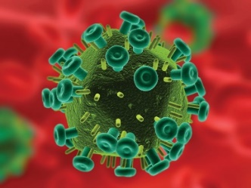  Is HIV alive? Why or why not?

The Cell Theory

The Cell Theory summarizes what we know about life:

- All living things are made of one or more cells | Unicellular (singled cell) __________________________  Multicellular ___________________________________
- All new cells come from pre-existing cells
- The cell is the basic unit of life

